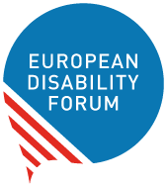

Ensuring disability rights in civil judicial cooperation
  - European Disability Forum - Position Paper
  - March 2022
Recommendations on civil aspects of the cross-border protection of vulnerable adults
This publication has received financial support from the European Union. The information contained in this publication does not necessarily reflect the official position of the European Commission.

Table of Contents
Table of Contents 2
Introduction 2
Civil judicial cooperation and persons with disabilities 3
Legal and policy background 4
Obligations under the UN Convention on the Rights of Persons with Disabilities 4
Obligations under the EU Strategy on the rights of persons with disabilities 2021-2030 5
The 2000 Hague Convention on the International Protection of Adults 5
Council conclusions on the protection of vulnerable adults across the EU 8
Issues related to cross-border situations involving vulnerable adults in the EU 8
Overview of legal capacity regimes in EU Member States 8
Examples of rights’ violations in cross-border cases 11
Conclusions and recommendations on ensuring disability rights in civil judicial cooperation 12
Annex 14
Glossary 14
Resources 15
Document credits 16

Introduction

The European Disability Forum
The European Disability Forum (EDF) is an umbrella organisation of persons with disabilities that promotes the rights of over 100 million persons with disabilities in the European Union. We are a unique platform which brings together representative organisations of persons with disabilities from across Europe. We are run by persons with disabilities and their families, and as such represent a strong, united voice of persons with disabilities in Europe.

Purpose of the position paper
This document was prepared to contribute to the consultation of the European Commission on Civil judicial cooperation – EU-wide protection for vulnerable adults. It provides recommendations to the European Union (EU) on the issue of cross-border legal protection of vulnerable adults and the use of the 2000 Hague Convention on the International Protection of Adults.

Acknowledgements
This position paper was prepared thanks to the contribution of EDF Board. It is based on research conducted by Haëndila Varela and Jolijn Santegoeds, consultants.

Civil judicial cooperation and persons with disabilities
The EU decided to address the “cross-border legal protection of vulnerable adults” in response to the needs of an ageing population and increased cross-border mobility in the Europe and all over the world.
According to the European Commission “more and more adults are unable to protect their own interests owing to an impairment or insufficiency of their personal faculties. They are thus vulnerable and need legal protection.”
The European Commission’s perspective on the protection of the “interests of vulnerable adults” is combining age and disability. The population most likely to be defined as “vulnerable adults’ entails people with intellectual and psychosocial disabilities, people with high support needs, people with Alzheimer or dementia, and older people with or without disabilities. Other population may also fall under this definition, in particular migrants and refugees, including those with disabilities, who are also more likely to find themselves in a cross-border situation.
“Vulnerable adults” in cross-border situations may face a number of problems in accessing the support they need.
The rules on protection of legal capacity vary across Member States, and mutual recognition in cross border situations can be problematic. Currently, there is no EU legislation governing the cross-border legal protection of vulnerable adults. Addressing civil judicial cooperation in the area of cross-border legal protection of “vulnerable adults” is important for the human rights of persons with disabilities in the EU.

Legal and policy background

Obligations under the UN Convention on the Rights of Persons with Disabilities
The EU and all its Member States ratified the UN Convention on the Rights of Persons with Disabilities (CRPD). Under the Convention they have the obligation to ensure equality and non-discrimination of all persons with disabilities (art. 5), equal recognition under the law (art. 12), liberty and security (art. 14), integrity of the person (art. 17) and independent living (art. 19).
The UN Committee on the Rights of Persons with Disabilities (CRPD Committee) explained the obligation to ensure equal recognition before the law in its General Comment No. 1. States Parties to the Convention must ensure that all persons with disabilities are recognised as persons before the law, which means that the legal capacity of all persons with disabilities must be respected, and that access to support they may require to exercise legal capacity must be provided, to enable people to make decisions that have legal effect. Supported decision-making mechanisms must replace deprivation of legal capacity such as guardianship. Support in the exercise of legal capacity must respect the rights, will and preferences of persons with disabilities and should never amount to substitute decision-making.
“Support” is a broad term that encompasses both informal and formal support arrangements, of varying types and intensity. For example, persons with disabilities may choose one or more trusted support persons to assist them in exercising their legal capacity for certain types of decisions, such as by advance directives or support circles, or may call on other forms of support, such as peer support, advocacy (including self-advocacy support), or assistance with communication and understanding.
The realisation of support to persons with disabilities in the exercise of their legal capacity might include measures relating to universal design and accessibility — for example, requiring private and public actors, such as banks and financial institutions, to provide information in an understandable format or to provide professional sign language interpretation — in order to enable persons with disabilities to perform the legal acts required to open a bank account, conclude contracts or conduct other social transactions.
In 2015, the CRPD Committee recommended to the EU to:
- Take appropriate measures to ensure that all persons with disabilities who have been deprived of their legal capacity can exercise all the rights enshrined in European Union treaties and legislation, such as access to justice, goods and services, including banking, employment and health care, as well as voting and consumer rights, in line with the Convention, as developed in the Committee’s general comment No. 1 (2014) on equal recognition before the law
- Step up efforts to foster research, data collection and exchange of good practices on supported decision-making, in consultation with representative organisations of persons with disabilities

Obligations under the EU Strategy on the rights of persons with disabilities 2021-2030
The EU Strategy on the rights of persons with disabilities 2021-2030 recognises that persons with disabilities often face difficulties in exercising their rights due to restrictions in their legal capacity may it be to participate in elections, or to conclude contracts or start a business. In addition, many persons with disabilities, adults and children, are segregated from community life and do not have control over their daily lives, in particular those living in institutions.
Under the Strategy, the Commission commits to:
- Work with Member States to implement the 2000 Hague Convention on the international protection of vulnerable adults in line with the UNCRPD, including by way of a study on the protection of vulnerable adults in cross-border situations, notably those with intellectual disabilities, to pave the way for its ratification by all Member States
- Collect good practices on supported decision-making
At the time of the publication of this position paper, EDF had not been involved in or informed about any of those two activities or under activities undertaken by the Commission to ensure equal recognition before the law of persons with disabilities.

The 2000 Hague Convention on the International Protection of Adults
The 2000 Hague Convention on the International Protection of Adults was adopted on 13 January 2000 at the Hague Conference on Private International Law. To date, 10 EU Member States have ratified the 2000 Hague Convention.
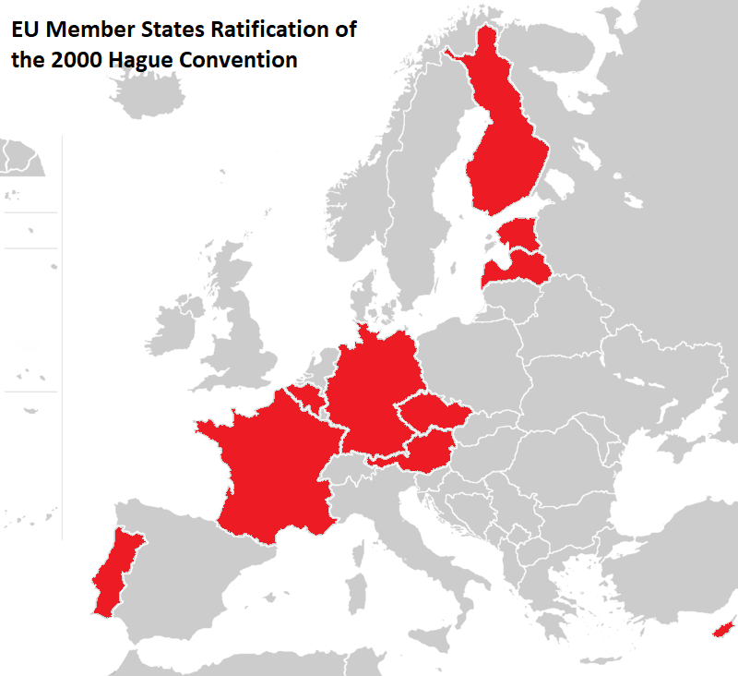
The “Hague Convention on the protection of vulnerable adults” seeks to determine which jurisdiction applies in cross border situations to take “protection measures”. The Hague Convention indicates which law will apply, based on e.g. nationality, residence and property location, resulting in a complex mix of fragmented and overlapping jurisdictions and different legal backgrounds to be applied simultaneously.
The Hague Convention also seeks to promote the mutual recognition and enforcement of “protection measures” between the ratifying members, and promotes cooperation between the authorities of those countries, through their Permanent Bureau, Special Commission and depository.
According to Article 1(1) of the 2000 Hague Convention, vulnerable adults are defined as “persons older than 18 years who, by reason of an impairment or insufficiency of their personal faculties, are not in a position to protect their interests”. Under the Hague Convention the vulnerability of the people concerned may result from various factors, including mental or physical impairments affecting the ability to make decisions or to assess the implications (e.g. the financial implications) of those decisions.
According to Article 1(2), the objects of the Convention are:
- to determine the State whose authorities have jurisdiction to take measures directed to the protection of the person or property of the adult;
- to determine which law is to be applied by such authorities in exercising their jurisdiction;
- to determine the law applicable to representation of the adult;
- to provide for the recognition and enforcement of such measures of protection in all Contracting States;
- to establish such co-operation between the authorities of the Contracting States as may be necessary in order to achieve the purposes of this Convention.
The “measures directed to protection” are specified in article 1 and article 3 of the 2000 Hague Convention and in the explanatory report on the Convention published in 2017. The measures may concern a variety of issues including determination of capacity, placement under or recognition of guardianship or curatorship, and “the placement of the adult in an establishment”. The explanatory report further adds: decision to have a person undergo a surgical operation and enforcement of placement and treatment measures (for example in psychiatry).
The approach of the Hague Convention is not in line with the CRPD.
In the Hague Convention, the word ‘measures’ is used as a general term, or as ‘measures of protection’, and these measures are not specified in detail, and neither is mentioned which forms of ‘measures of protection’ are acceptable and which not, so this offers no concrete protection or rights. Also, the Hague Convention does not differentiate between voluntary and involuntary ‘measures of protection’. For example, the term ‘guardianship’ is covering both voluntary and involuntary regimes, while involuntary regimes should be identified as human right violations, and while support agreements based on free and informed consent can be considered as a good practice. A distinction between voluntary and involuntary measures is essential.

Council conclusions on the protection of vulnerable adults across the EU
In May 2021, the Council adopted Council conclusions on the protection of vulnerable adults across the EU. The Council Conclusions invites Member States to ratify and implement the 2000 Hague Convention.
The Council Conclusions also make references to the CRPD and note that “the CRPD brought about a paradigm shift in relation to the legal capacity of persons with disabilities by affirming that all persons with disabilities should enjoy legal capacity on an equal basis with others”. It states that “the 2000 Hague Convention should be implemented in full respect of the CRPD.”

Issues related to cross-border situations involving vulnerable adults in the EU
The European Disability Forum is concerned by the numerous issues amounting to human rights violations that may arise in cross-border situations involving vulnerable adults in the EU.
While the EU and all its Member States have ratified the CRPD and commit to protect disability rights under the EU strategy for the rights of persons with disabilities and national strategies, yet, rules and practices in place at national level do not yet ensure the right to equality, equal recognition before the law, physical and moral integrity and independent living of all persons with disabilities.
By promoting the ratification of the 2000 Hague Convention by its Member States, without supporting the development of measures in compliance with the CRPD, the EU risks to promote the application of rules that violate the CRPD and the rights of “vulnerable adults”.

Overview of legal capacity regimes in EU Member States
Even though all EU Member States have ratified the CRPD and are bound by its provisions, including Article 12 which prohibits substituted decision-making and call on State parties to incorporate supported decision-making in their legal capacity regimes, practice shows that a majority of EU Member States do not comply with this obligation. There is no unity and rather a diversity of legal capacity regimes.

Substituted decision making regimes
Guardianship regimes are still widely governing the legal capacity of persons with disabilities. Full and/or partial guardianship are provided for in 12 Member States.
8 Member States still do not incorporate any provisions on assistance in decision-making for persons who need such support. These States thus contravene to their obligations under Article 12 of the CRPD since their legislation is based on substituted decision-making regimes and does not provide for any form of support in decision-making.
While some EU Member States removed the possibility to deprive a person of their legal capacity from their legal framework, others still provide for the loss of capacity for persons “with mental impairments or other health issues limiting their capacity to decide for themselves and manage their interests”.

Supported decision making regimes
13 Member States have amended their laws to introduce supported decision-making regimes. Among these States, Belgium, France and Portugal expressly stressed that their new legal capacity regimes were guided by the principles of necessity, subsidiarity and proportionality. Six Member States abolished full guardianship.
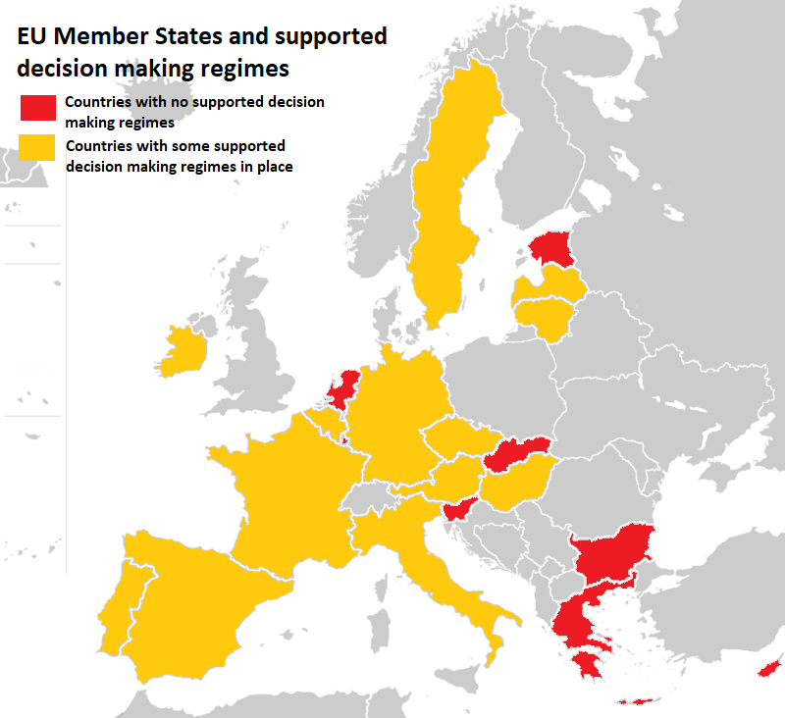
However, an important issue that must be highlighted is the lack of resources allocated to the authorities and social services in charge of deciding on or providing assistance in decision making. The study of legal capacity regimes in the EU shows that in some Member States where supported decision-making has been introduced and substituted decision-making measures remain, judges continue to use the latter and order more restrictive protection measures. This is the case in Germany, Belgium and Czech Republic, where civil society raised the issue on the fact that competent authorities lack the resources to analyse and assess the person's situation to offer them measures adapted to their needs and preferences.

Powers of representation
Power of representations are arrangements where adults organise in advance for a time when they might be unable to look after their own interests, or have difficulty to express consent or their will and preferences. Power of representations include for example advance directives, or the voluntary designation of a representative.
Five EU Member States do not include provisions on powers of representation allowing a person to appoint a representative ahead of a future temporary or permanent loss of decision making skills.
It is also important to note that while powers of representation may have advantages to understand and respect the will and preferences of the persons, in some cases the person may change their mind. It is crucial that the will and preferences of the person is interpreted in the present moment and not by what they may have expressed time ago.
In addition, it is unclear to which extend persons with disabilities are aware of the measures of powers of representation in their countries, or in other countries. No specific information related to persons with disabilities and powers of representation was found in research undertaken in preparation of this position paper.

Examples of rights’ violations in cross-border cases
As shown in the section above, legal capacity regimes in the EU are fragmented with rules going from full substituted decision-making regimes like plenary guardianship where an appointed guardian is taking any decision on behalf of the person, to forms of supported decision-making regimes where the people are supported to make their decisions by a person of trust who respect their will and preferences.
In cross-border cases, blunt rules on competences and recognition of legal capacity measures, such as those set in the 2000 Hague Convention, may lead to recognition of full guardianship measures or accept the institutionalisation or involuntary treatment in psychiatry, in violation with the CRPD. This can even lead to the consolidation of such human rights violations in EU Member States that may have started to move away from substituted decision-making regimes, institutions and coercion.

Consideration on protection: examples of persons experiencing mental health crisis abroad
Several situations of “vulnerable adults in cross-border situations” were analysed in preparation this position paper. It appeared that the problems and human rights violations faced, would not be addressed and remedied by the Hague Convention.
For example, the person who migrated from a non-EU country to an EU-country, and who suffered detention which devastated his mental health and turned him into a “vulnerable adult”. He died after weeks of being neglected in restraints in a mental health institution in an EU country. The protection and support which he needed was not there. The Hague Convention would not have brought any change to this horrendous situation. On contrary, the Hague Convention even allows for coercive interventions to be executed cross-border.
Another example concerns a person who fled from a mental health institution and went to another country, and who was found by the police, hospitalised at the nearest available institution, and repatriated from a country that is not a member of the Hague Convention. Their biggest problem came afterwards with the foreign hospital bill and the insurance clauses (exclusion clauses). The Hague Convention would not change this situation either.
The actual lack of protection regarding “vulnerable adults in cross border situations” is not remedied by the Hague Convention.

Conclusions and recommendations on ensuring disability rights in civil judicial cooperation
The European Disability Forum (EDF) recognises the importance of adoption and application of conflict of laws treaties as a means to provide legal certainty, avoid gaps and promote the uniform application of substantive international law including in the EU.
However, conflict of laws legislation should not lead to human rights violations of the person impacted by the measures at stake.
EDF is particularly concerned that the promotion of the ratification of the 2000 Hague Convention in its current form risks to contribute to the fragmentation of international law, especially in light of the wide ratification of the UN Convention on the Rights of Persons with Disabilities (CRPD). Its implementation could lead to direct violations of the CRPD by EU Member States.
EDF recommends that:
- The EU does not promote the ratification of the 2000 Hague Convention which in its current form reflects an out-dated and currently non-human rights compliant understanding of “protection” which has been clearly superseded by the CRPD.
- The EU develops measures to facilitate the abolition of substituted decision-making in all EU Member States, as well as to accelerate desinstitutionalisation, end coercive treatment and placement, and develop supported decision-making practices.
- The EU issues guidelines for EU Member States on cross-border protection on “vulnerable adults” based on the CRPD.
- Measures adopted to deal with conflicts of law and cross-border protection of “vulnerable adults” are based on the promotion of and compliance with the CRPD. States should prevent the application of legislation by another State in the context of cross-border issues and private international law when it does not comply with international human rights law, including the CRPD.
- The EU and its Member States systematically consult and involve representative organisations of persons with disabilities in all discussions related to the “protection of vulnerable adults” and measures that may impact the rights and lives of persons with disabilities in Europe and beyond.

Annex

Glossary
Cases with cross-border implications are situations and/or judicial or administrative proceedings that concern two or more countries. A case with cross-border implications may arise when for instance:
- ‘Vulnerable adults’ or their representatives are in another country, or are nationals of a country other than the one of the courts or competent authorities to which the case is referred;
- Powers of representation granted in one country need to be recognised in another country;
- ‘Vulnerable adults’ own assets or are involved in contractual arrangements or legal proceedings in a country other than the country in which they habitually live;
- ‘Vulnerable adults’ who benefit from protection measures taken in one country plan to move to another country, or their placement in an establishment or residential facility in another State is being considered.
Disabled people’s organisations (DPOs) / organisations of persons with disabilities: organisations comprising a majority of persons with disabilities who represent the interests and defend the human rights of persons with disabilities through self-representation and advocacy.
Guardianship: guardianship allows some people to make life choices for others. Often this follows a court decision that considers that the person “is not able” to make day-to-day and/or life-changing decisions. Sometimes, people under guardianship are not allowed to vote, marry or take care of their children (see also ‘legal capacity’).
Institutionalisation: the fact of being placed, or placing someone, in an institution. An institution is any residential care where residents are isolated from the broader community and/or compelled to live together; residents do not have full control over their lives or over the decisions that affect them; and requirements of the organisation itself tend to take precedence over the residents’ individual needs.
Legal capacity: Legal capacity is the ability to hold rights and duties (legal standing) and to exercise those rights and duties (legal agency). It is the key to accessing meaningful participation in society.
Mental capacity: Mental capacity refers to the decision-making skills of a person, which naturally vary from one person to another and may be different for a given person depending on many factors, including environmental and social factors.
Powers of representation: Power of representations are arrangements where adults organise protection in advance for a time when they might be unable to look after their own interests, such as appointing a representative. Powers of representation are also known as private mandates, and different names are used in the EU, such as ‘lasting (or enduring) powers of attorney’, ‘mandats de protection future’, ‘Vorsorgevollmachten’.
Substitute decision-making: Substitute decision-making regimes can take many different forms, including plenary guardianship, judicial interdiction and partial guardianship. However, these regimes have certain common characteristics: they can be defined as systems where (i) legal capacity is removed from a person, even if this is in respect of a single decision; (ii) a substitute decision-maker can be appointed by someone other than the person concerned, and this can be done against his or her will; and (iii) any decision made by a substitute decision-maker is based on what is believed to be in the objective “best interests” of the person concerned, as opposed to being based on the person’s own will and preferences.

Resources
- Convention on the Rights of Persons with Disabilities
- Council conclusions on the protection of vulnerable adults across the EU
- General comment No. 1 (2014) on Article 12: Equal recognition before the law
- Joint statement by the Special Rapporteur on the rights of persons with disabilities, Gerard Quinn, and the Independent Expert on the enjoyment of all human rights by older persons, Claudia Mahler: Reflections on the Hague Convention (2000) on the International Protection of Adults
- Study ‘Interpreting the 2000 Hague Convention on the International Protection of Adults Consistently with the UN Convention on the Rights of Persons with Disabilities’

Document credits
This document was prepared by Marine Uldry, EDF Human Rights Officer.
Contact: marine.uldry@edf-feph.org
The European Disability Forum
Mundo Madou
Avenue des Arts 7-8
1210 Brussels, Belgium.
www.edf-feph.org
info@edf-feph.org
This publication has received financial support from the European Union. The information contained in this publication does not necessarily reflect the official position of the European Commission.

According to the European Commission, “Because of the disparity in rules, vulnerable adults may experience serious delays and legal or practical barriers to having a protection measure recognised when they cross borders within the EU. In addition, due to the lack of common rules for cooperation and language barriers, competent authorities and courts may experience problems in cooperating with the authorities of another State when a vulnerable adult has moved or when information from another State is sought.”
The CRPD makes a difference between mental capacities and legal capacities. See glossary in annex.
The Hague Convention is not an UN-based Convention. The Hague Convention is made by a group of States (the Hague Conference on Private International Law - HCCH), who positioned themselves on the domain of justice, health and international cooperation, all of which are state obligations.
Austria, Belgium, Cyprus, Czech Republic, Estonia, Finland, France, Germany, Latvia and Portugal
Article 4(1)(f) of the Convention, detailed in para. 40 of the explanatory report
Article 4(1)(i) of the Convention, detailed in para. 45 of the explanatory report; and Article 11(1) of the Convention, detailed in para. 84 of the explanatory report.
Bulgaria, Cyprus, Denmark, Finland, France, Hungary, Luxembourg, Malta, Netherlands, Poland, Romania and Slovenia.
Bulgaria, Cyprus, Estonia, Greece, Luxembourg, Netherlands, Slovakia, Slovenia.
10 Member States: Bulgaria, Croatia, Denmark, Finland, Hungary, Italy, Lithuania, Luxembourg, Poland and Slovenia
Austria, Belgium, Czech Republic, France, Germany, Hungary, Ireland, Italy, Latvia, Lithuania, Portugal, Spain and Sweden.
Czech Republic, Croatia (but maintained partial guardianship), Germany, Latvia, Spain and Sweden.
ENNHRI and MHE, Implementing supported decision-making – Developments across Europe and the role of NHRIs, 8 June 2020, p.14, available at: https://www.mhe-sme.org/wp-content/uploads/2020/06/Report-ENNHRI-and-MHE-Implementing-supported-decision-making.pdf
Ibid. p.12
Mental Health Europe (MHE), Mapping & Understanding Exclusion in Europe, December 2017, p.78, available at: https://mhe-sme.org/wp-content/uploads/2018/01/Mapping-and-Understanding-Exclusion-in-Europe.pdf
Bulgaria, Cyprus, Estonia, Poland and Slovakia
https://www.repubblica.it/rubriche/liberta-illiberta/2021/12/07/news/abdel_latif_il_migrante_morto_perche_e_morto-329282968/

