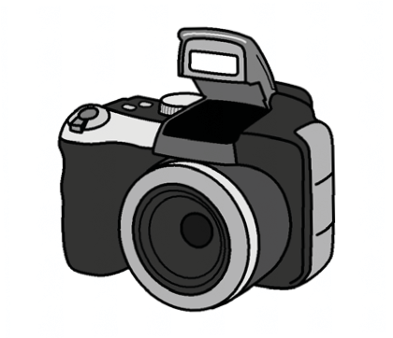
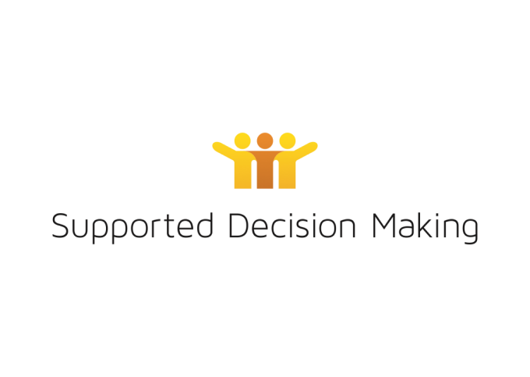
Photo consent form

What is a photo consent form? You can tell us if we can use your photos. We will use the photos of you to show people how we talk to each other.

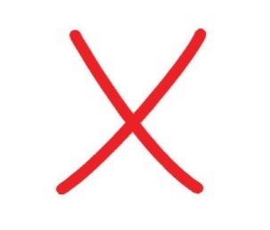
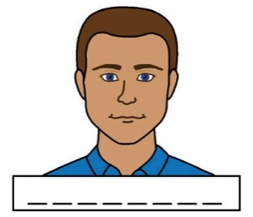 Write your name 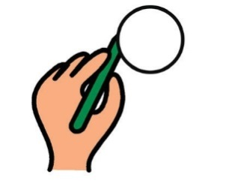 Please circle no or yes.

No, I do not want you to use any photos of me. You have finished this form.

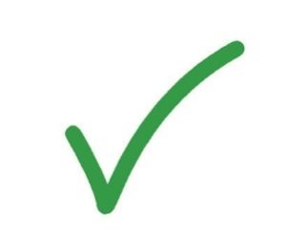
Yes, you can use photos of me.

Turn the page and tell us what we can use your photos for.

How long can we use your photos?
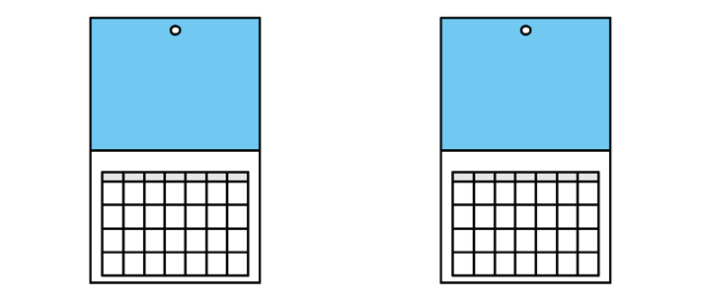 2 years

What can we use your photo for?

Make a mark next to Posters Brochures Fact sheets Newsletters Magazines Journals Books

Scope’s website Conferences/presentations Training
Social media. For example, Facebook, Twitter

2

Give this form back to us.

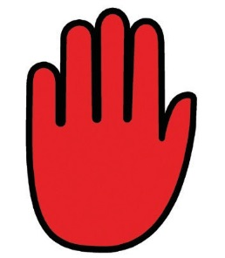
If you want us to stop using photos of you, you can tell us.

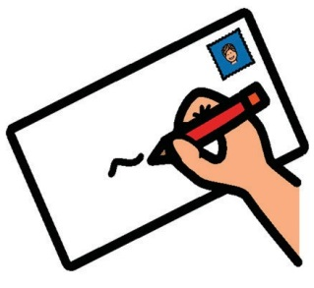 Write your address 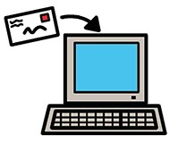 Email 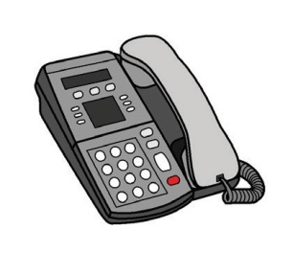 Phone 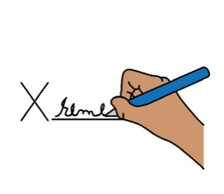 Sign your name
Date

3

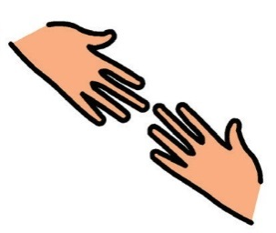
You can get someone to sign the form for you.

Sign your name Date

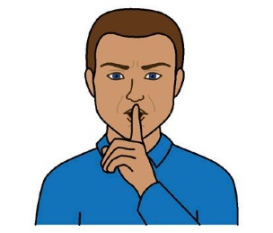
What happens with this form? We will keep this form private. We will keep this in a safe place.

You have finished this form. Thank you

Images we used on this form

Mayer-Johnson says we can use their Picture Communication Symbols

© 1981 – 2010.

Valuing People ClipArt © Inspired Services, UK. www.inspiredservices.org.uk.

Who can you speak to for more information?

WAiS

94207252

admin@waindividualisedservices.org.au

