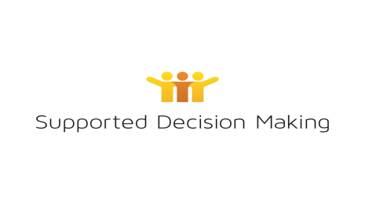

Use of photos and videos

Over the past 6 months, we have taken photos and videos at

The Supported Decision Making Project

The photos and videos might be of

- You
- Your family

WAiS wants to tell people about the work we do.

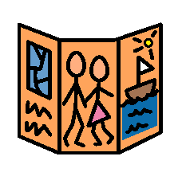
WAiS might use the photos and videos for:

- WAiS Website
- WAiS Facebook page
- Videos
- Brochures
- Posters

It’s ok to say yes and it’s ok to say no.

You can tell us if you change your mind.

We won’t give out any information about you with the picture or video. We won’t tell people your

  - Name
  - Address
  - Email

PLEASE CIRCLE ONE.

- PHOTOS

Can we use a picture of you and your friends/family to tell people about the supported decision making project?

Yes Don’t know* No

*someone will help you answer your questions

- VIDEOS (Audio/visual recording)

Can we use a picture or video of you and your family to tell people about the supported decision making project?

Yes Don’t know* No

* someone will help you answer your questions

Name of people in photos or videos:

Name of adults:

I have read this form.

I understand what is written in this form.

Name of person:

Signature: _

Date:

………………………………………………………………………………………………………………

Person who supported the person with this form:

Relationship to the person:

Signature:

Date:

