Lord Ashley’s Independent Living Bill
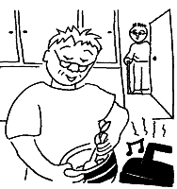

An Easy Read Guide

Written by Caroline Ellis, January 2006

What is in this paper on page..

1. What is this paper about? 3
2. Why do we need a Bill on Independent Living? 4
3. The aims of the Bill (what it is trying to do) 5
4. Who is a disabled person? 6
5. Choosing how and where you live. 6
6. You say what your needs are. 7
7. The rules about who can get help. 7
8. What help should disabled people expect? 8
9. Your own budget for support services. 8
10. The right to advocacy and help with communication. 10
11. What happens when you move to a different area? 11
12. Disabled people helping other disabled people. 11
13. Charging you for support services 11
14. What if social services say ‘we don’t have money to help you’? 12
15. Housing 13
16. Disabled children, young people and families 13
17. Making sure all disabled people’s rights are protected 14
18. Carers 14
19. Getting problems sorted out 15
20. What good will the Bill do 15
21. Questions for you 16
22. How to tell us your views 17
23. Wordlist 18

- What is this paper about?

Lord Ashley has asked us to help him write a Bill to give disabled people stronger rights to Independent Living.

Independent living means having choice, freedom and control over your own life. It means that you decide where to live and how to live your life. It means you get all the support you need to make decisions and take part in society.
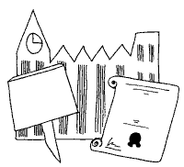

Lord Ashley wants to introduce the Bill in the House of Lords in May this year.

The Bill will mainly cover England and Wales. A few things in the Bill will cover Scotland.
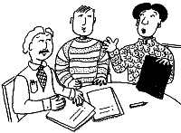
We are talking to a lot of disabled people to find out what you want the Bill to say.

- Why do we need a Bill on Independent Living?

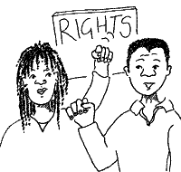

We need to get changes to the law so that disabled people have strong rights to support for independent living.


We have a law about fairness when you try to get a job or when you use services like shops, banks and transport. This is called the Disability Discrimination Act.


But the law about social care and who gets support from social services is not very good.

There are lots of barriers to independent living for disabled people:


- Some disabled people don’t get any help from social services

- You don’t have individual rights to get support like advocacy.


- You don’t have a right to say ‘NO’ if social services say you should live in residential care.

3. The Aims of the Bill (what it is trying to do)

The first things we will write down in the Bill are its aims – what it is trying to do. We will say:

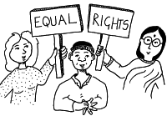
- The aim of the Bill is to give disabled people choice, freedom and control over their lives.

- Social services and other bodies must try and make sure disabled people are able to have this choice and control. That means being able to:
- decide how to live your life
- get a good education and qualifications
- work and be friends with non-disabled people
- look after your children and have a good family life
- do other things that help people in your community
- have fun doing sport or shopping or hobbies like everyone else
- choose the support you need to do all these things

For children it also means being able to play with other children.

- Every disabled person must be treated with respect. No one should be treated unfairly because they are older or because they are black or gay. Social services need to make things better for disabled people in these groups.

- Councils and health services must work together with other people in their area to make this happen.

- Who is a disabled person?

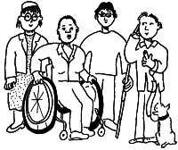
The law about social care says that disabled people are people who are blind or deaf or ‘who have a ‘mental disorder’ or who are ‘handicapped’. Disabled people don’t like the way it talks about disability. It doesn’t talk about the barriers people face.

- Choosing how and where you live
Some disabled people are told that they should live in a residential home. The Bill will say that you can say “NO” to this.

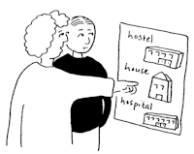
The Bill will say ‘disabled people can choose where to live and how they want to live’. If you want a home of your own you should have one.
If you want to live with your mum and dad or with some friends that’s okay to. It is your decision.

- You say what your needs are

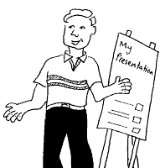
The law says that social services have to look at your needs. But it doesn’t give you the right to say ‘these are my needs’. What you say should be the most important thing. The Bill will also say you must be given support if you need it to tell social services what your needs are.

- The rules about who can get help
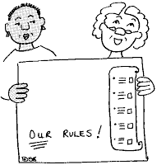

Every social services department has its own rules about who it will help. These rules are called ‘eligibility criteria’.

The Government has tried to make the rules fairer but it has not worked.

One of the problems is that if social services don’t have much money they say ‘we can only help people with high support needs’. So sometimes if you just need a bit of help you may not get any help at all.

The Bill will say every disabled person who needs help should get some help.

- What help should disabled people expect?

There will be a Code of Practice with the Bill. This Code of Practice will have rules about what help disabled people must be given by social services.

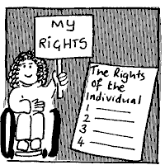
For example, it will say you must be given support to do basic things like go to college to get qualifications or visit your friends and family.

So even if social services don’t have much money there will be some things they must make sure they do.

- Your own budget for support services

If you don’t want social services to give you support services you can ask for money so you can buy your own. This is called ‘direct payments’.

Not many people with learning disabilities use direct payments. The Bill will tell social services to make sure people with learning disabilities know about these ‘direct payments’.


We think direct payments are a very
good thing. But there is a problem. You can’t use direct payments for things like money to make your house more accessible. You have to go to a different part of the council for that.

Disabled people say ‘we are fed up of having to ask lots of different people for money for different things’.


The Government says it wants something better than ‘direct payments’. It says every disabled person who needs support should be able to have an ‘individualised budget’.

An individualised budget is money for a disabled person to spend on all the things they need to take part in society.
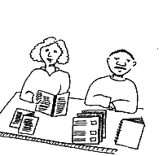

You could get help to buy the support you need. Or you could say ‘I don’t want to look after a budget, I want the council to buy me the things I need.’
It would be your choice!

We like this idea and we will write this into the Bill.

- The right to advocacy and help with communication.
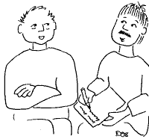

The Bill will give disabled people the right to an independent advocate. An independent advocate is someone who supports you to make decisions or speaks up for you if you need them to. Being independent means they are separate from services and the council.

Councils will need to make sure there are good advocacy services in their area.

An advocate can be another disabled person with the same disability as you. This is called ‘peer advocacy’ and there needs to be funding and support for this kind of advocacy too.
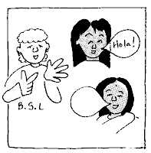
The Bill will give disabled people the right to support for communication. This support could be things like:

- an interpreter for a deaf or deafblind person
- a book of pictures or symbols to help a child with learning disabilities
- computer equipment

- What happens when you move to a different area.

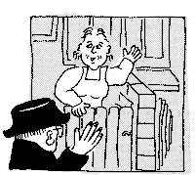
If you move home to a different part of the country you have to ask your new social services department for support. If you had good support in the place you used to live, you might not get the same support in a new area.

We think that if social services agree that you need help you should be able to take that help with you if you move to a new place.

- Disabled people helping other disabled people

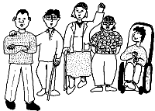
There are some good organisations of disabled people. They help other disabled people with independent living or with advocacy.

The Bill will say that councils and the Government must make sure there are organisations like this in every local area.

- Charging you for support services


Some disabled people get help from social services but are asked to pay towards the service. The rules about when local councils can charge people for some of the costs of their services are not really fair. The Bill will make the rules fair.

We will also think about stopping councils asking disabled people to pay for services.

- What if social services say ‘we don’t have money to help you’?
Sometimes councils can just say ‘we have not got the money’ and so a disabled person can’t have any support. This is a big problem. What can be done about it?

- First it is too easy for a council to say ‘we have no money’. Councils should try harder to say ‘yes’ before they say ‘no’. They should explain what they are going to do to sort out the problem.

- Second, councils do need extra money to spend on independent living for disabled people.

If we give councils more money now we think that social services and health will save money later on.

How? Well a lot of the things in the Bill will save money – like some of the changes we want in housing.

- Housing

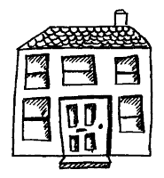

A lot of money is wasted because new houses are not built to be accessible to disabled people.


The Bill will say all new houses must be easy for disabled people to get around. This would save a lot of money. Councils would not need to pay for so many adaptations for disabled people.

- Disabled children, young people and families

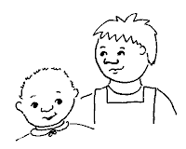
The Bill will let disabled children and their families have an ‘individualised budget’ if they want one.

We will ask disabled children and their families what other things they want in the Bill. Many families want a ‘key worker’. A key worker is someone who makes sure they get information about important things. A key worker helps sort out all the support a family needs.

- Making sure all disabled people’s rights are protected

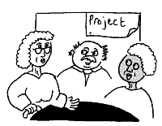
Older disabled people are not treated fairly. You can’t get a benefit to help with getting around if you start having problems when you are over the age of 65. Some money for independent living is only given to people who are under 65. The Bill will stop this unfair treatment.


Black disabled people are also treated unfairly. People can’t always get information in a different language and in easy words. Sometimes people who work in social services or health have bad attitudes towards black people. The Bill will make sure black disabled people have stronger rights to independent living and respect.

Different groups of disabled people might need different kinds of support. We are talking to people with learning disabilities, people who use mental health services, people with autism and other groups. We want to make sure the Bill helps everyone.

- Carers

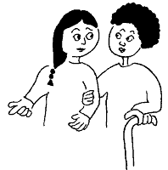
If disabled people get more support then that is good for carers too. More women can go out to work. Carers need support too and we will work with carers groups. A lot of disabled people are carers too.

- Getting problems sorted out

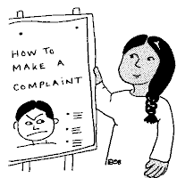
The Bill will make it easier to complain to your council if you are not getting the support you need.

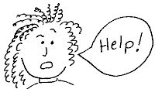
If you have a problem it should be sorted out quickly. You should not have to go to court to get your rights. There are groups the Government set up which look at what social services and health services do. We are going to talk to them to see if they could help sort problems out for disabled people.

- What good will the Bill do?
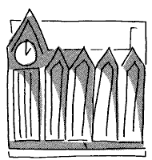
We hope Lord Ashley’s Bill will be supported in the House of Lords and get support from MPs of all different political parties.

We know we can’t make it the law yet. But the Bill will:
help explain to people what independent living means and why it is good thing.

help us build more support for independent living and make the Government take action more quickly.

21. Questions for You
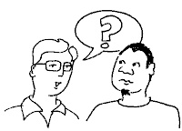

We want to know what you think about this Bill.

Is there anything we have said that you disagree with?

What should the Bill say about rights for people with learning disabilities?

When is it really important to have an advocate to support you?

Can you tell us about your experiences of getting support from social services or health services? What good things have happened to you? What bad things have happened to you?

Please tell us what you think by the end of April this year.

22. How to tell us your views


You can email us: at independentlivingbill@drc-gb.org


You can talk to us on the telephone

Neil Coyle 020 7543 7039

Tim Gunning 020 7543 7030

Caroline Ellis 020 7543 7038

If you want to support and campaign for the Bill you can talk to:

Sinead Gordon on 020 7543 7036.

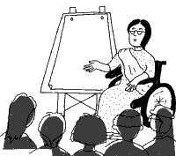

If you want someone to come and talk to your group about the Bill please ask Sinead.

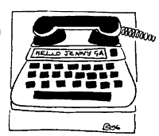

You can contact us via textphone on 020 7543 7002 – just ask for someone from the Independent Living Bill Team.

23. Word list

Bill
A Bill is an idea for a new law. It is not just the Government who can introduce Bills into Parliament – MPs and members of the House of Lords can do this too. Any Bill needs to be supported by the Government to become law. And a Bill does not become a law until it has all been agreed by Parliament – so you need other political parties to agree to it too.

Direct Payments
Direct Payments means when disabled people are given money by their council to buy the services they need.

Eligibility Criteria
These are the rules councils make about who can get help from their social services department.

Independent advocate.
An independent advocate is someone who supports you to make decisions or speaks up for you if you need them to. Being independent means they are separate from services and the council.

Independent Living
Independent living means having choice, freedom and control over your own life. It means that you decide where to live and how to live your life. It means you get all the support you need to make decisions and take part in society.

Individualised budgets
These are like direct payments only better! You could get money to spend on a lot more things.

Key worker
A key worker is someone who makes sure families with disabled children get information about important things. A key worker helps sort out all the support a family needs.

Peer advocacy
This is like independent advocacy but means you are supported by another disabled person who has the same disability as you.

Social Services
A Social services department is the group of people in a council which organises support services for disabled people, older people and other people who need help. If you want support services you ask social services to look at your needs.

Society
Society is about the people we share the country with and how people work and act together.

