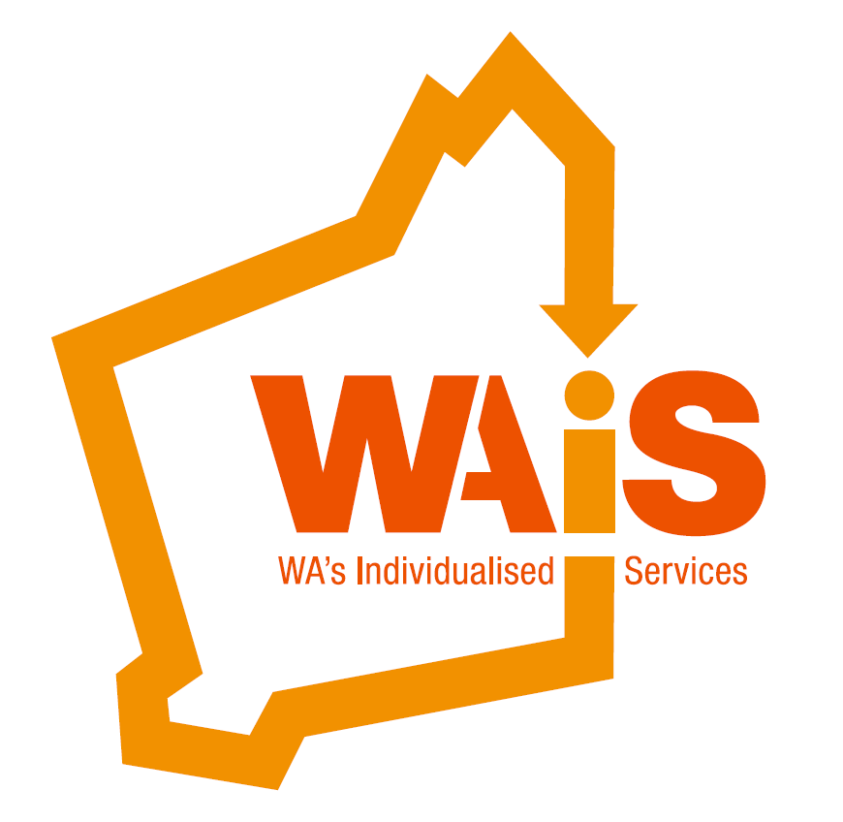
SUBMISSION COVER SHEET

Person: Leanne Pearman (corresponding author)
Organisation and position: Executive Officer, WAIS
Address: City West Lotteries House 2 Delhi St Suburb/town: West Perth
State: WA Postcode: 6005
Email address: l.pearman@waindividualisedservices.org.au Phone: (08) 9420 7252
Mobile: 0408 672 205
Website: www.waindividualisedservices.org.au

This submission:
Contains NO confidential material

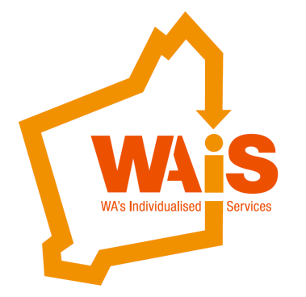
Position Statement

Review of the Workers’ Compensation and Injury Management Act 1981 Discussion Paper
Introduction
ABOUT WAIS
Western Australia’s Individualised Services (WAIS) is an incorporated association of disability services providers in Western Australia who specialise in the provision of individualised services to people with disability to enable them to remain in their family home or live in their own home and to engage with their local community.
WAIS comprises of 27 member organisations drawn from Perth and rural Western Australia who utilise individualised funding from the Western Australian Disability Services Commission and other sources (government and private) to support more than 1,000 people with disability in individualised support arrangements. Many of these arrangements have been in place for more than a decade.
Approximately one third of the people supported are younger people with disability who are supported to live in their family home. Another third are adults who are supported to live in their own homes (usually provided through public housing) with the live-in and/or visiting support that they need. The remaining third are adults and teenagers supported to participate in various community activities during weekdays and on weekends.
Further information about WAIS and its member organisations (or any enquiries related to this submission) can be obtained from the corresponding author of this WAIS submission. WAIS members include: Baptistcare, Community Vision, Directions Family Support Association, Enable Southwest, Future Living Trust, Inclusion WA, Lifestyle Solutions, My Place, Community Living Association, Perth Home Care Services, Ability Focus, One 2 One, Anglicare, Family Support WA, Identity WA, Midway Community Care, Mosaic Community Care, Rocky Bay, Valued Independent People (VIP), Workpower Inc, UnitingCare West, Activ, Autism Asosciation of WA, Interchange, Multicultural Services of WA, Rise and Senses.

Work for private householders (pp48-49)
33. It is proposed a person who is engaged by a homeowner to provide domestic services in a private home is not a ‘worker’ and therefore excluded from workers’ compensation liability and insurance requirements. The exclusion will not apply if the person providing the service is employed by someone who is not the owner or occupier. This clarifies a liability does not attach to a homeowner for domestic services but will attach to any employer other than the owner or occupier with whom the person providing the work has an employment relationship (e.g. cleaner is engaged by a cleaning company to provide services to a homeowner).

WAiS members support a large number of people with disability and/or their families. Many of these individuals and families who have individualised funding and supports, manage these independently or with some administrative support from a disability service provider. These support arrangements, known as self and shared managed in the disability sector, are of a private and domestic nature.
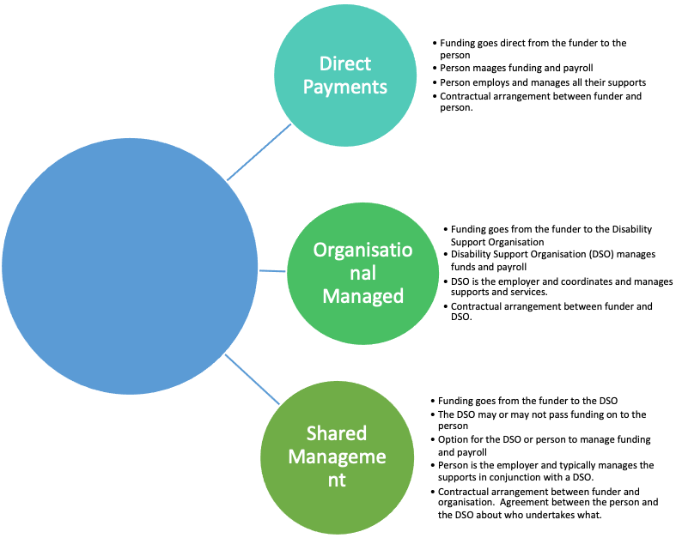
WAiS members defines the following ways in which people choose to manage their funding and supports:
Individuals with disability and/or their families

Self-directed support is where people direct their support and decide how to best use the resources available to them. This can be done with direct payments, organisation management and shared management. Some specific examples are described below:
1. (Shared-Management)
I am Dan, a 25-year-old young man who receives support through funding from Disability Services
Commission (DSC). I live in my own unit and not in the family home. My mother obtains two
main types of support for me on my behalf under a Shared Management arrangement with a Disability Support Organisation whereby they provide an administration and bureau service. I have an advisor that currently assists me for a small number of hours each week. The advisor helps me:
• Plan and communicate with family members;
• Actively build networks in the community;
• Liaise with organisations, Government and others on my behalf;
• Seek out new opportunities (social/educational and employment related); and
• Train/support/direct his personal assistants
The advisor is paid $50 an hour on a casual rate. As noted above, currently the number of hours worked per week is small. It is important that I am able to build a long-term relationship with the advisor and therefore the intention is that the same individual will be used for an extended duration. The current “advisor” has an ABN and as such tax is not withheld from payments made. The advisor spends part of the time working with me in my home as well as some time away from my home.
I also use personal assistants who work with me, my family and the advisor. The personal assistants provide routine support, including:
• Household tasks such as shopping, cleaning and budgeting; and
• Travel with me to outings, sports, voluntary work etc
A number of personal assistants are used and are paid $30 per hour on a casual rate. The current
“personal assistants” have provided a 'Statement by Supplier' form and as such tax is not withheld from payments made.

2. (Self Management)
I am John, a young man with a disability and I receive approximately $53,000 individualised funding from the Disability Services Commission (DSC). I live with my parents and sister in regional WA. This funding is Self Managed with minimal support from a Disability Support Organisation. Together with my family, we enlist the help of individuals to support me whilst my family is away from the house on an as-needed basis on an hourly rate of $25. The number of hours required varies between days and weeks depending on our situation. The support is typically provided by transient workers (e.g. backpackers). The support provided to me by the support worker will also vary depending upon the time of the day that care is required but can include transportation, providing meals, assistance with hygiene, entertainment, general supervision and undertaking some general household chores. My family (in the capacity as my legal guardian) make the payments to the support worker on my behalf. The support worker provides a ‘Statement by Supplier’ declaration and as such tax is not withheld on the payments made to them. The support workers are typically not professional carers with qualifications or training due to the nature of the support.
3. (Shared Management)
My son Eli, who has severe and complex disability, has my assistance to employ people under a private and domestic agreement to support him to do the things he wants to do. I have been set up as an Employer, and I manage the recruiting staff, organising his supports, helping him with any aspect of his life and daily living.
Eli has been allocated Individualised Funding through the Disability Services Commission and out of this funding we contract a Disability Support Organisation to manage the Administrative and Bureau service. The remainder of the funding we manage as a family in employing support staff and managing Eli’s support services.
Eli's staff are currently paid between $25 and $30 an hour depending on their level of performance. Typically Eli's staff are highly qualified professional people who are excited by the possibility of doing innovative work with somebody who has complex needs and a strong desire to explore life.
4. (Organisation Managed)
I am Susan and I receive Individualised Funding through the Disability Services Commission. I have a Disability Support Organisation and I need that organisation to completely manage and administer all of my funding. This includes recruiting staff, organising my supports, helping me with any aspect of my life and daily living.

 | 1 | 2 | 3 | 4
Living arrangement for Personal Assistant/Support Worker | Does not live with Dan | Lives with John | Does not live with Eli | Does not live with Susan
Engagement of Advisor/Skilled Support Worker | Skilled advisor and support worker | None | Skilled support worker | Skilled support worker
Regular rostered support hours | Yes | No | Yes | Yes **
Job Description and Duty statement | Yes | No | Yes | Yes **
Recruit staff and supervise | Yes | Yes | Yes | Yes **
Superannuation paid | Yes ** | None | Yes ** | Yes **
Workers Compensation paid | Yes ** | None | Yes ** | Yes **
Public Indemnity Insurance paid | Provided through household insurance policy | None | Yes ** | Yes **
PAYG Tax paid by person/family/organisation | No – ABN and Statement by Supplier used | No | Yes ** | Yes **
NB: ** the organisation is contracted to manage these services)
The workers in scenarios 1, 3 and 4 are engaging in work that is based and designed around the person, in the same manner and with the same responsibilities and requirements to meet the Disability Service Standards, regardless of whether it is an organisation or the person/family managing the individuals funding.
The difference is that the day-to-day management and co-ordination of the supports and services in 1,2 and 3 are by the individual and family, and in 4, it is by the organisation. The choice of individuals and families to manage their own supports should not disadvantage those workers who are engaged to provide the support and whom are currently covered by the Workers Compensation Act.
With the introduction of the National Disability Insurance Scheme (NDIS), it is expected that there will be a significant increase in individuals and/or families managing their funding. Ensuring the workers in these arrangements have some consideration and safeguard will be important as the workforce in this area grows. Please see an excerpt of the NDIS Rules below:
In 2010 The Australian Government asked the Productivity Commission to carry out a public inquiry into a long-term disability care and support scheme. In March 2013 the NDIS legislation was passed and the NDIS Act 2013 was created, along with the scheme and the Agency—National Disability Insurance Agency.
Division 3—Managing the funding for supports under participants’ plans
42 Meaning of managing the funding for supports under a participant’s plan
(1) For the purposes of this Act, managing the funding for supports under a participant’s plan means:
(a) purchasing the supports identified in the plan (including paying any applicable indirect costs, such as taxes, associated with the supports); and
(b) receiving and managing any funding provided by the Agency; and
(c) acquitting any funding provided by the Agency.
(2) For the purposes of the statement of participant supports in a participant’s plan, in specifying the management of the funding for supports under the plan as mentioned in paragraph 33(2)(d), the plan must specify that such funding is to be managed wholly, or to a specified extent, by:
(a) the participant; or
(b) a registered plan management provider; or
(c) the Agency; or
(d) the plan nominee.
http://www.comlaw.gov.au/Details/C2013C00388

Recommendation
WAiS recommends that whereby a person as a worker is engaged, such as in the scenarios 1, 3 and 4, they should be considered workers under the Workers Compensation Act and/or for the assessment in determining a worker, be flexible for these scenarios to be considered.

