**NDIS Management Options**

You are able to choose three different ways to manage your NDIS plan. You can choose one or a combination of these management options for different parts of your plan. Your three options are:

### 1. Self Management 2. Plan Management 3. Agency Management

**Self Management**

* Self management is when you have total control and responsibility for managing the money (funding) and supports in your plan.
* You get your funding (payment requests) from the NDIS and pay your supports and services.

# Plan Management

* Plan management is when you get a Plan Manager to get your funding (payment requests) from the NDIS and pay your supports and services for you.
* Your Plan Manager needs to be registered with the NDIS.
* If you have a Plan Manager, then additional money (funding) will be in your plan to pay your Plan Manager for their services.

# Agency Management

* Agency management is when the NDIS pays your service providers for you.
* Your service providers are responsible for getting funding (payment request) from the NDIS to cover the cost of the supports and services they provide you.

## SELF MANAGEMENT

NDIS Funding Me/Nominee Service Provider

## PLAN MANAGEMENT

NDIS Funding Plan Manager Service Provider

## AGENCY MANAGEMENT

NDIS Funding Service Provider

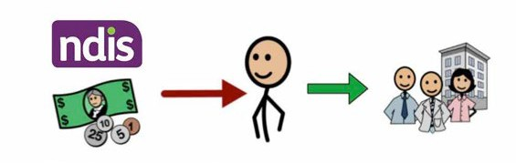

### [www.waindividualisedservices.org.au](http://www.waindividualisedservices.org.au/)





|  |  |  |  |
| --- | --- | --- | --- |
|  | **Self Management** | **Plan Management** | **Agency (NDIA) Management** |
| Can I get (purchase) services from NDIS registered providers? | Yes | Yes | Yes |
| Can I get (purchase) services from non-registered providers? | Yes | Yes | No |
| Can I hire my own workers? | Yes | Yes  (Although, not all Plan Managers  are set up for payroll) | To be Confirmed by NDIA |
| Do I have legal obligations if I hire my own workers? | Yes | Yes | Yes |
| Do I need to get the funding (payment requests) and pay for my supports and services? | Yes | No | No |
| Do I have to keep records? | Yes | No  (Your Plan Manager does) | No |
| Do I have to follow the NDIS Price Guide? | No | Yes  (Your Plan Manager does) | Yes |
| Can I get information about what I have spent my budget on and how much is left? | Yes | Yes | Yes |
| Do I get extra money (funding) in my plan for this management option? | No | Yes  (There will be additional funding specifically to pay your Plan Manager) | No |
| Do Service Bookings need to be made? | No  (Not for the parts of your plan that are Self Management) | Yes | Yes |

Current as at September 2018

[**www.waindividualisedservices.org.au**](http://www.waindividualisedservices.org.au/)



|  |  |  |  |
| --- | --- | --- | --- |
| Do I need a separate bank account? | Yes  (This is strongly  recommended **!**  by NDIA) | No | No |
| Do I have to have a Service Agreement? | No  (Although it is **!**  strongly recommended) | No  (Although it is **!**  strongly recommended) | No  (Although it is **!**  strongly recommended) |
| Do I have sole responsibility for the quality of my supports and services? | Yes | Yes | No  (Registered Providers have already gone through a quality assurance process to become registered with  the NDIS) |
| Do I have to check how I am going with achieving my goals in my plan before a plan review? | Yes  (You may be requested to seek reports from providers for your plan review) | Yes  (You may be requested to seek reports from providers for your plan review) | Yes  (Service Providers may be requested to provide  a progress report to the NDIA) |