SUPPORTING PEOPLE WITH DISABILITY
TO MAKE THEIR OWN DECISIONS

PRESENTED BY MICHELLE BROWNING

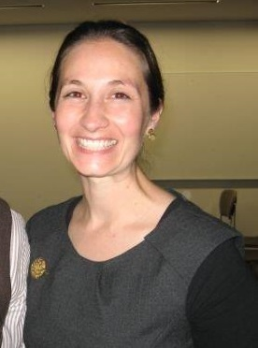
Do you support someone with a disability to make decisions?

Are you interested to learn about how important the relationship you have with that person is in helping them live the life that is meaningful to them?

WAiS invites you to a workshop designed to help you reflect on the important role you have as a decision supporter for a person with disability.

The workshop will be based on current research into the practice of supported decision-making from Australia and overseas. It will explore two key issues:

- The importance and the defining qualities of support relationships which have been shown to lead to good supported decision-making practice, and

- The essential role you have in responding to the person's will and preferences during the supported decision-making process. A model of decision-making support will be explored

MONDAY 11 DECEMBER 2017
9.30AM TO 12.30PM FLOREAT

ABOUT THE PRESENTER:

The workshop will be facilitated by Michelle Browning, a consultant who is passionate about assisting individuals and organisations to develop their confidence and skill in the practice of supported decision-making.

In 2010, Michelle was awarded a Churchill Fellowship to explore supported decision-making in England and Canada. Since then she has worked developing and implementing trials of supported decision-making practice in New South Wales and Victoria in collaboration with an advocacy organisation, two guardianship offices and the NDIS.

Michelle has reached the conclusion of her doctoral research at La Trobe University exploring the practice of supported decision making in Canada. Michelle is excited to share her insights gained through research and practice with practitioners based in Perth, Western Australia.

COST: (inc GST)
WAiS member individual $10
Non member individual $20
WAiS member service provider $40
Non member service provider $80
Cost includes morning tea
WHERE: The Boulevard Centre, 99 The Boulevard,
Floreat (under Cambridge Library)

PARKING: Free parking up to 3 hours permitted in shopping centre
carpark however cars should be parked at the east end of the carpark.

REGISTRATION:
http://www.eventbrite.com.au/o/was-individualised-services-7277295963

INFORMATION: Mary Butterworth 9485 1997 (Mon & Thu) OR
m.butterworth@waindividualisedservices.org.au

