Community of Practice

[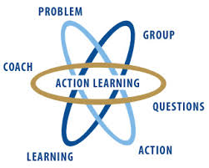](http://www.google.com.au/imgres?imgurl=http://www.wial.org/uploads/attachments/219c70933aff6b2a6d08c687a6cbb6b765.jpg&imgrefurl=http://www.wial.org/about-wial&h=258&w=323&tbnid=we91VuKH8sul9M:&zoom=1&docid=frqClq2y8OCgfM&ei=iPhWVNLjEeG7mwX5hYDgAQ&tbm=isch&ved=0CDkQMygQMBA&iact=rc&uact=3&dur=428&page=2&start=10&ndsp=15)



Action learning

This is a good place to briefly, but effectively, describe your product or services.



Title Text

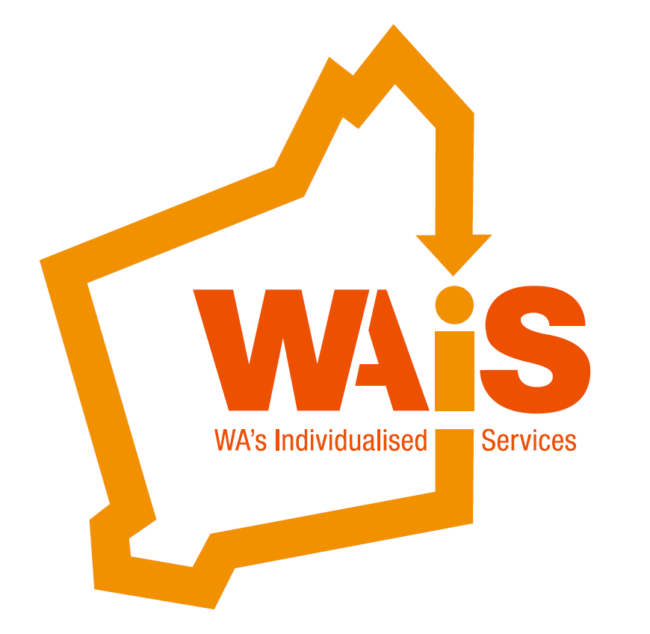

**Leading Culture Change**  **Presented by: Kate Fulton**

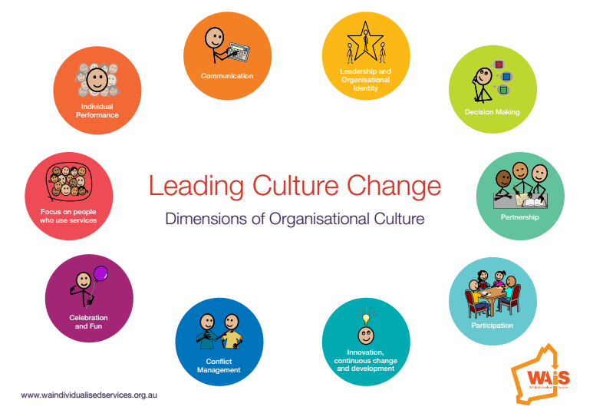

The Leading Culture Change workshop aims to provide organisations with a framework and tools for assessing and understanding organisational culture as well as designing interventions to build and manage organisational cultures that best fit the change agenda.

This workshop is for people who have some responsibility for steering the organisation into the future, including navigating and responding to people and families in an individualised context.

Call WAiS 9485 1997 for further information.

**Leading Culture Change - “the way we (an organisation) are and how we behave and act together”.**

* Many good reasons exist for seeking to understand the culture of an organisation. It is particularly important where significant change is required.
* Over the last year WAIS has worked with a number of Providers and people who are engaging their own support to identify critical elements that create a successful organisational culture – elements that support person centred practice.
* This workshop will share this learning and support participants to understand their current culture and identify strategies to shape and influence the culture to be the kind that recognises and values staff who deliver excellent support and services.

**About the Presenter:**

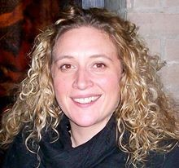

**Kate Fulton:**

Kate has worked alongside people and families for many years working in a range of settings and communities. Kate is passionate about individuals directing their own lives and feels that she has been incredibly privileged to meet people and families who have shared their experiences of helpful supports and creative approaches to change.

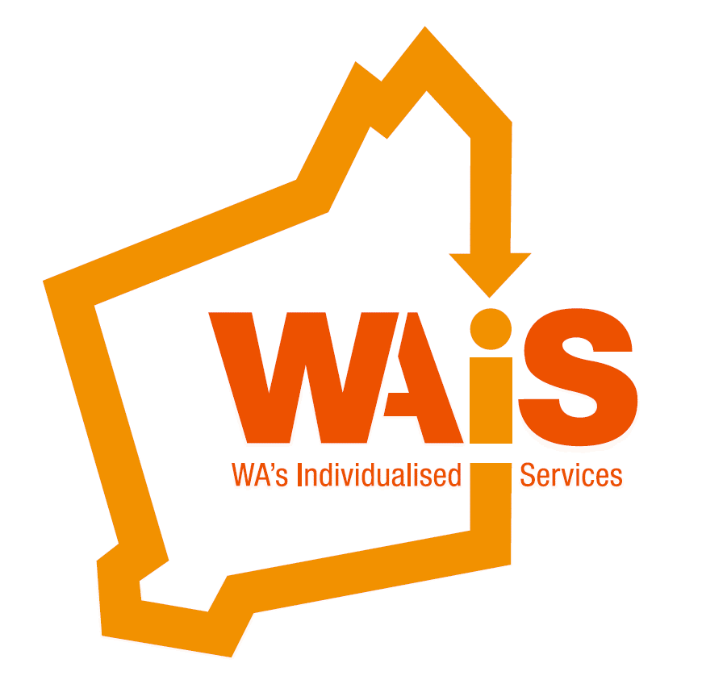

**Leading Culture Change**

**When:**

Tuesday 18th October 2016

**Time:**

9am (registration)

9:15am – 4pm

**Venue:**

The Boulevard Centre

99 The Boulevard

Floreat WA 6014

**To register please email us;** [**events@waindividualisedservices.org.au**](mailto:events@waindividualisedservices.org.au)

**call 08 9485 1997 or book on Eventbrite:**

[**https://www.eventbrite.com.au/e/leading-culture-change-tickets-27402673133**](https://www.eventbrite.com.au/e/leading-culture-change-tickets-27402673133)

**Cost:**

**Provider Program participants** FREE

(when chosen as part of your event package)

**WAiS Members** $50

(Individual with disability /family member)

**Non Members** $90

(Individual with disability/Family member)

**WAiS Members (Organisations)** $190

**Non Members (Organisations)** $210

*Catering provided

