

Community of Practice
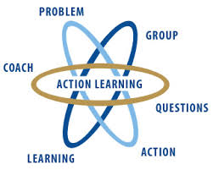
Action learning

This is a good place to briefly, but effectively, describe your product or services.
Title Text
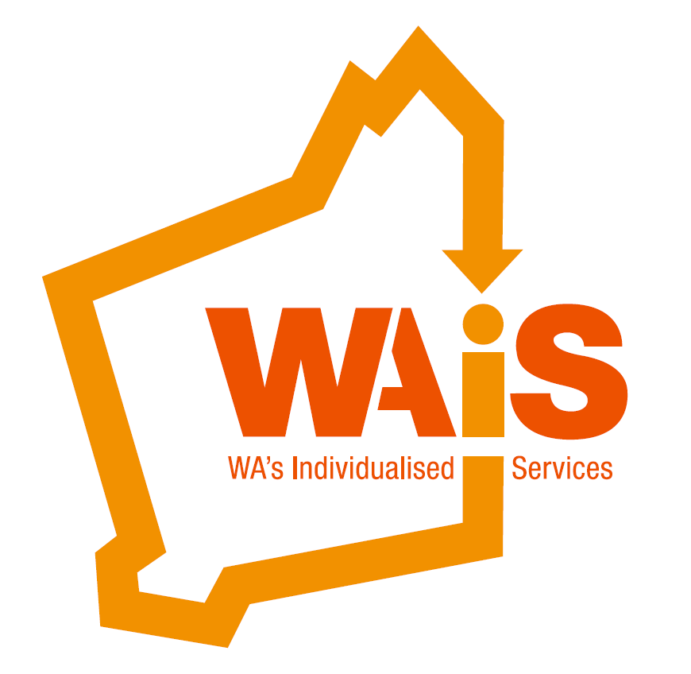
Designing and Creating Individual Support Presented by: Kate Fulton

Designing and Creating Individual Support – As organisations respond to people and families who are directing their supports, WAIS is learning that the ability to turn a funding plan into a real living design that is shaped around the individual is critical.

How do we assist people to turn line items and support clusters into real purposeful support to live a life that's right for the person?

WAIS has a strong history in supporting people to develop individualised supports based on who the person is and what matters to them. Individual Service Design is a process that works to really understand the person, explore possibility and turn a plan into reality.



Join Kate on this workshop where she will share examples and experiences of designing supports that are flexible, in budget and purposeful. We will also explore individual service design tools and techniques, making this workshop a practical experience that can be implemented straight away.

This workshop is for people who have responsibility for responding to people and families who have plans from the National Disability Insurance Schemes or people who have responsibility to design support solutions.

About the Presenter:

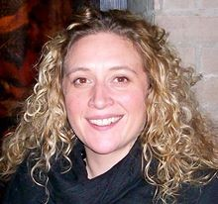
Kate Fulton

Kate has worked alongside people and families for many years working in a range of settings and communities. Kate is passionate about individuals directing their own lives and feels that she has been incredibly privileged to meet people and families who have shared their experiences of helpful supports and creative approaches to change.

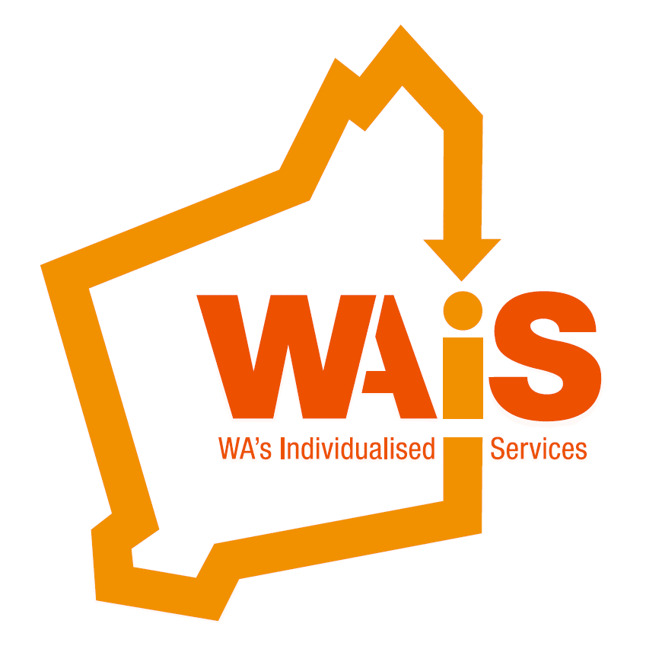
Designing and Creating Individual Support

When:
Friday 11th November 2016

Time:
9am (registration)
9:15am start – 4pm

Venue:
The Rise (Upstairs)
28 Eight Avenue
Maylands

*Catering provided

To register please email us; events@waindividualisedservices.org.au
call 08 9485 1997 or book on Eventbrite
https://www.eventbrite.com.au/e/designing-and-creating-individual-support-tickets-27728102501

Cost:
Provider Program participants FREE (when chosen as part of your event package- please call 94851997)

WAiS Members (Individual) $50
(Individual with disability/family member)

Non Members (Individual) $90
(Individual with disability/Family member)

WAiS Members (Organisations) $190

Non Members (Organisations) $210

