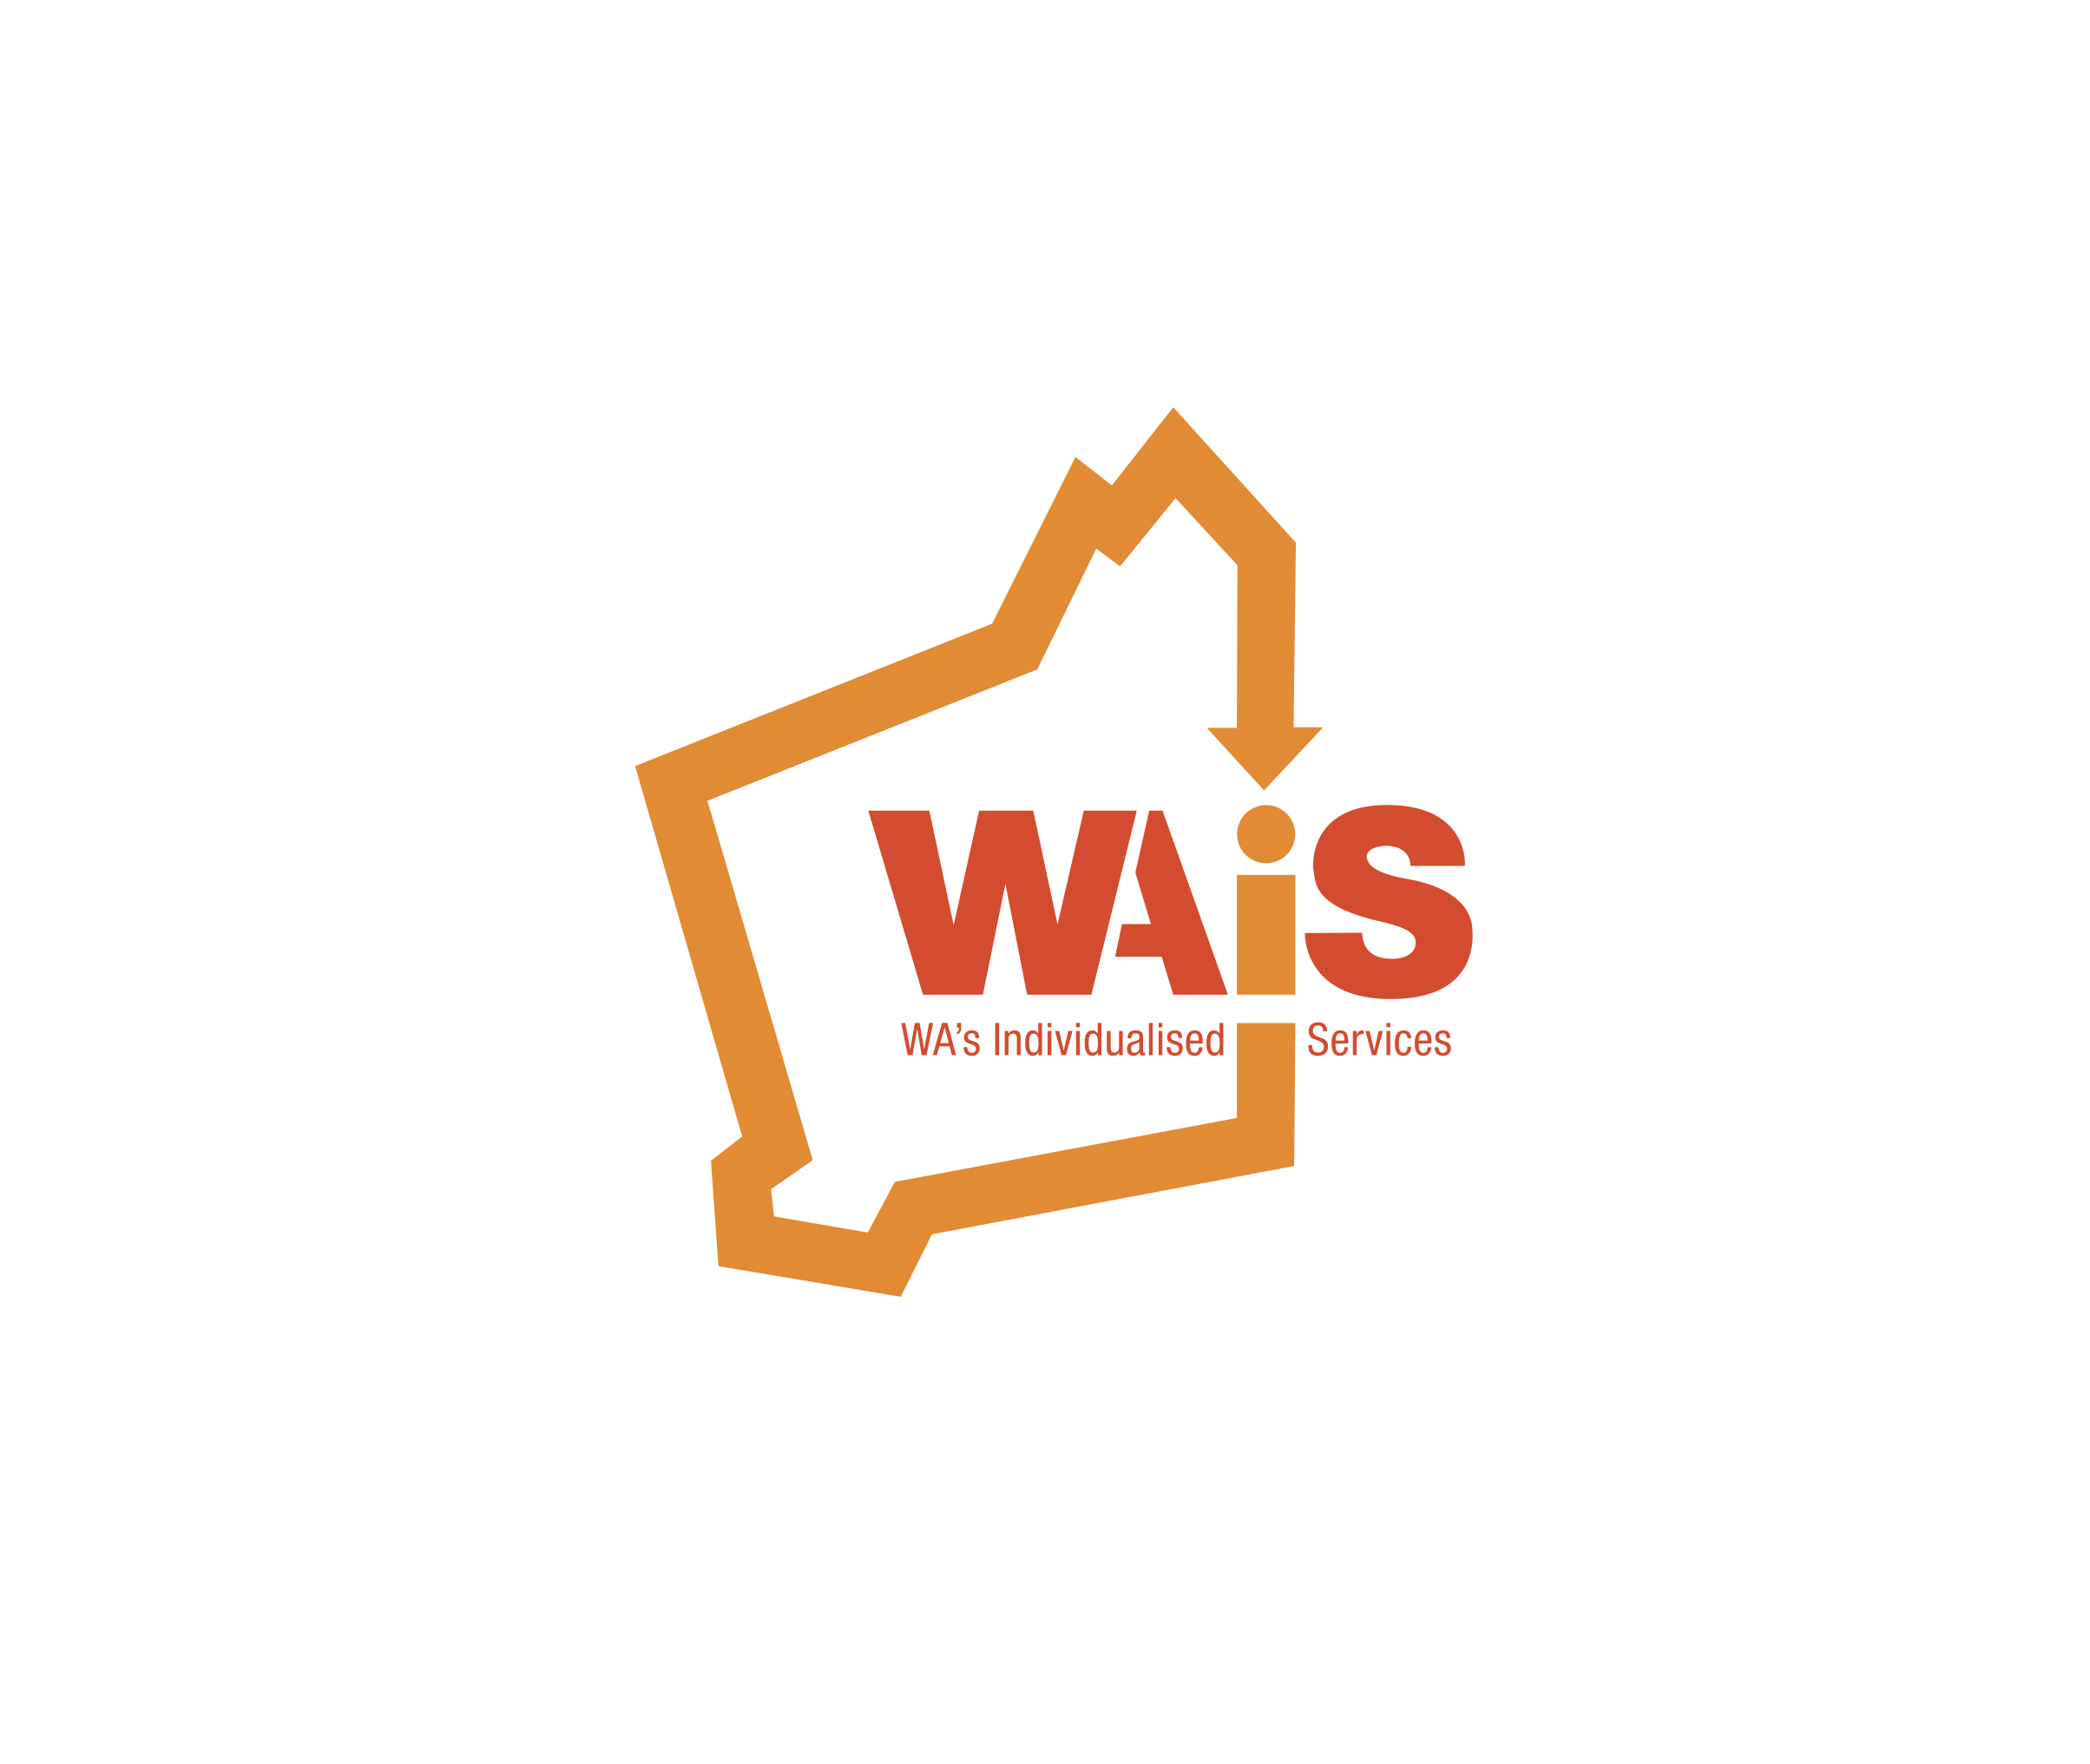

**Western Australia’s Individualised Services**

**Election of Committee of Management 2016/17**

Dear Member,

**Election of Committee of Management 2016/17**

Date: Wednesday 26th October 2016

Time: 12:30pm – 3:00pm (light lunch provided)

Venue: The Boulevard Centre, 99 The Boulevard, Floreat, WA 6014

Under the WAiS Rules of Association, the Committee of Management is elected at each Annual General Meeting. Please find enclosed a nomination form. Six (6) Committee Members are to be elected. Voting Representatives are eligible to nominate for Committee of Management positions.

Once elected, the Executive Committee positions of Chairperson and Deputy Chairperson will be appointed by the Committee at the first meeting following the AGM. As per the Rules, the position of Secretary is filled by the Chief Executive Officer.

**The closing date for nominations is Wednesday 12th October 2016**

Completed nomination forms can be mailed to:

Attention: Secretary (Leanne Pearman)

Western Australia’s Individualised Services

Bluenote Building Unit 16, 162 Colin St, WEST PERTH, WA 6005

🖂 [admin@waindividualisedservices.org.au](mailto:admin@waindividualisedservices.org.au) 🕿 08 9485 1997

The Committee play an integral role in providing strategic guidance and support to the WAiS team. WAiS has enjoyed the privilege of a passionate and dedicated Committee, who have contributed to the success of WAiS during its formative years. We invite you to take the opportunity to contribute in this role as we continue our journey.

If you have any questions regarding the nomination process, please contact

Su-Hsien Lee [s.lee@waindividualisedservices.org.au](mailto:s.lee@waindividualisedservices.org.au)



**Western Australia’s Individualised Services**

**Election of Committee of Management 2016/17**

**Nominee (person being nominated)**

Name: ____________________________________________________________

Member Organisation (if applicable): _____________________________________

**Nominator (person nominating you)**

Name: ____________________________________________________________

Member Organisation (if applicable): _____________________________________

Signature: __________________________________________________________

Date: _____________________________________________________________

**Acceptance of Nomination by Nominee**

Signature: __________________________________________________________

Date: _____________________________________________________________

**Validation**

The Secretary of WAiS has received the nomination and declares that the nomination has been submitted in accordance with Clause 10 of the Rules of Association.

Signature: __________________________________________________________

Date: _____________________________________________________________