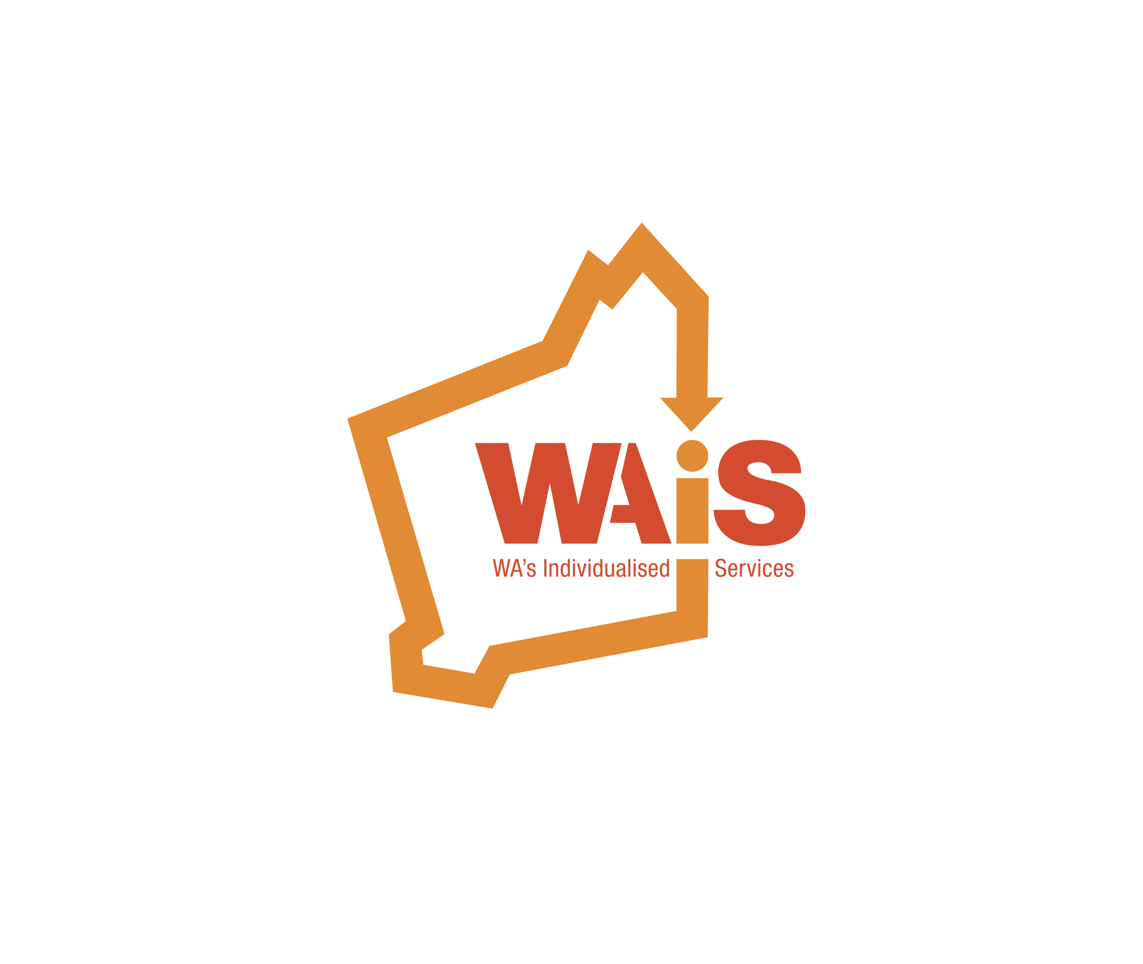

**Invitation to our 2016**

**Annual General Meeting**

When: Wednesday 26th October 2016

Time: 12:30pm – 3:00pm (light lunch provided)

Location: The Boulevard Centre

99 The Boulevard

Floreat, WA, 6014

Room: Boulevard North

RSVP: 12th October 2016

Western Australia’s Individualised Services is pleased to invite you to join us for our Annual General Meeting on Wednesday 26th October 2016

Please RSVP and register via Eventbrite: <https://www.eventbrite.com.au/e/wais-annual-general-meeting-2016-tickets-26438118123>