Thursday Sept 15th

9:00am (registration) 9.30am to 4.00 pm

Meadow Springs Sporting Facility, Function Room, Oakmont Avenue,

Meadow Springs, 6210

Cost:

Provider Program participants FREE

(when chosen as part of your event package)

WAIS Members (Individual) $90

Non Members (Individual) $120

WAiS Members (Organisations) $190

Non Members (Organisations) $210

Catering provided

Book on Eventbrite

https://www.eventbrite.com.au/e/supported-decision-making-tickets-26577278355

**Please also check Eventbrite to register for the follow-on workshop, 'Preparing to Plan' on September 20**.

Workshop facilitated by

Jaquie Mills & Susan Stanford

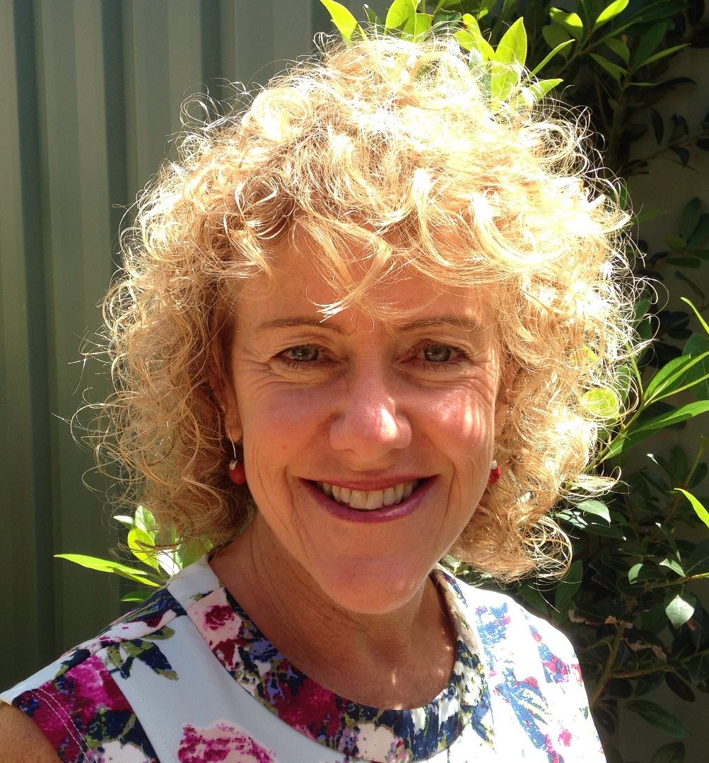 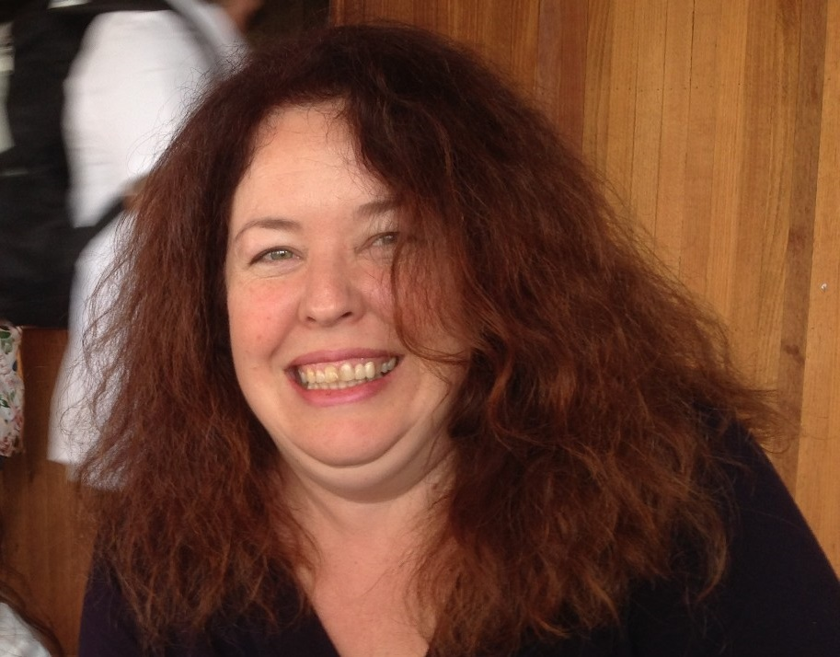

**Do you work with, or care for a person with communication support needs?**

**Do you wonder if you really know how they want to be supported?**

**Or what choices they need you to support?**

**How do you ensure that people you care about are self-directing their lives?**

Supported decision making is a term used to refer to a range of practices whereby people with disabilities are assisted to make or implement their own decisions.

In 2014, WA’s Individualised Services undertook a project to develop the sector’s knowledge and skill in supported decision making to ensure self-direction is a possibility for all. We worked in partnership with people, families and the sector to develop a practical approach and resources for supported decision making.

At this workshop, you will practice with tools which identify:

What is the decision?

Who are the right people to assist?

What’s the right way to communicate the decision?

What’s the right information to include?

How can we assist the person to weigh it up?

How do we hear the person’s decision?

How do we support the person to act on the decision?

Participants will be provided with a DVD and a copy of the WAiS [Supported-Decision-Making](http://waindividualisedservices.org.au/supported-decision-making-project-resources/) resource.

This workshop is suitable for individuals, families and participants across the field of human services. Please let us know if you have communication support needs for decision making.

You can view and download the resources from the WAiS website   
[Supported-Decision-Making](http://waindividualisedservices.org.au/supported-decision-making-project-resources/)



Supported Decision Making  
Workshop



Community of Practice

[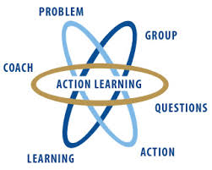](http://www.google.com.au/imgres?imgurl=http://www.wial.org/uploads/attachments/219c70933aff6b2a6d08c687a6cbb6b765.jpg&imgrefurl=http://www.wial.org/about-wial&h=258&w=323&tbnid=we91VuKH8sul9M:&zoom=1&docid=frqClq2y8OCgfM&ei=iPhWVNLjEeG7mwX5hYDgAQ&tbm=isch&ved=0CDkQMygQMBA&iact=rc&uact=3&dur=428&page=2&start=10&ndsp=15)



Action learning

This is a good place to briefly, but effectively, describe your product or services.



Title Text