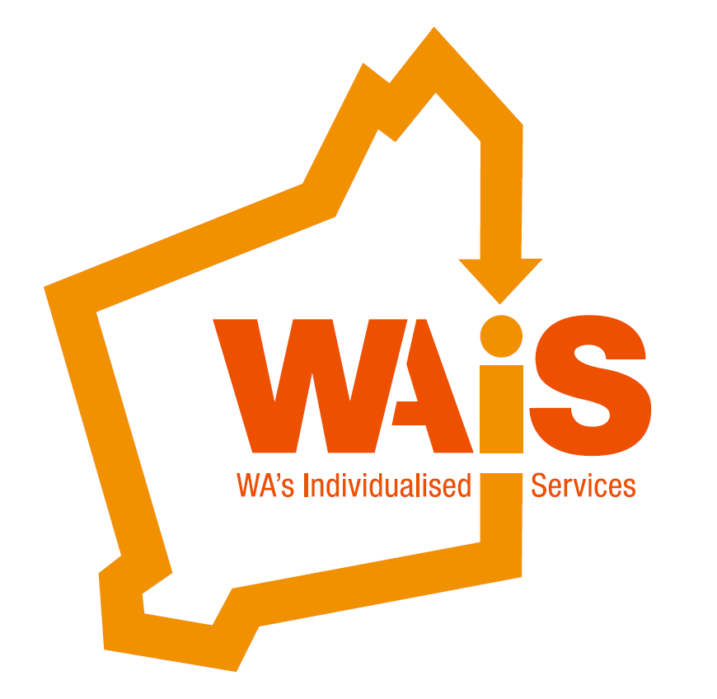

Community of Practice

[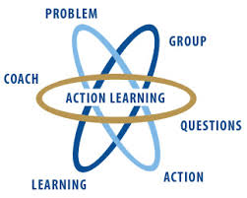](http://www.google.com.au/imgres?imgurl=http://www.wial.org/uploads/attachments/219c70933aff6b2a6d08c687a6cbb6b765.jpg&imgrefurl=http://www.wial.org/about-wial&h=258&w=323&tbnid=we91VuKH8sul9M:&zoom=1&docid=frqClq2y8OCgfM&ei=iPhWVNLjEeG7mwX5hYDgAQ&tbm=isch&ved=0CDkQMygQMBA&iact=rc&uact=3&dur=428&page=2&start=10&ndsp=15)



Action learning

This is a good place to briefly, but effectively, describe your product or services.



Title Text

Person Centred Planning Workshop

Introducing the   
Preparing to Plan Guide



Meadow Springs Sporting Facility, Function Room, Oakmont Avenue,

Meadow Springs, 6210

Cost:

Provider Program participants FREE

(when chosen as part of your event package)

WAiS Members (Individual with disability/family member) $50

Non Members (Individual with disability/Family member) $90

WAiS Members (Organisations) $190

Non Members (Organisations) $210

Catering provided

Book on Eventbrite:   
<https://www.eventbrite.com.au/e/person-centred-planning-introducing-the-preparing-to-plan-guide-tickets-21693203957>

Tuesday Sept 20th,

9am (registration)

9:30am-4pm

Here’s how [Clickability](https://clickability.com.au/planning-to-plan-for-the-ndis/) rated this resource.

*This might just be my favourite! WAiS’s Preparing to Plan resource is made up of a range of “cards” which are like check lists of things to think about before you begin planning. It comes with a set of 10 cards that are about 7-10 pages long. Each one asks questions and offers suggestions about an area of life like communication, work, and my favourite, sexuality and intimacy (an area that seems to have been missed in all the other resources – oops!). For example, on the Sexuality and Intimacy card it asks, “Do you need help to explore your beliefs and values? Suggestion: put language about love, commitment, marriage and other things to do with relationships into your communication device or system. All the suggestions have little boxes next to it for you to tick if this is something you’d like.*

Workshop facilitated by Susan Stanford & Jaquie Mills

**Do you work with, or care for a person who needs support?**

**Are you clear about what a person centred approach to support means?**

**Would you like a refresher, and new resources for person centred support?**

If it’s a **Yes** to all of those questions, then please join us for this one-day workshop. We’ll explore the foundations of a person centred approach to support, and **Why** they are important. Start preparing now by reflecting on someone you are currently supporting. What’s easy about enacting a person centred approach? What’s hard about enacting a person centred approach? At this workshop, you’ll have an opportunity to identify a range of new strategies to deepen your person centred work.

We’ll introduce you to a new, easy to read and use [planning resource](http://waindividualisedservices.org.au/preparing-to-plan-resources/), developed to support people, families and carers when preparing to plan. This resource was developed by WAiS in collaboration with people with disability and their families.

This workshop is suitable for individuals, families and participants across the field of human services. Please let us know if you

have communication support needs.

.

