Community of Practice

[](http://www.google.com.au/imgres?imgurl=http://www.wial.org/uploads/attachments/219c70933aff6b2a6d08c687a6cbb6b765.jpg&imgrefurl=http://www.wial.org/about-wial&h=258&w=323&tbnid=we91VuKH8sul9M:&zoom=1&docid=frqClq2y8OCgfM&ei=iPhWVNLjEeG7mwX5hYDgAQ&tbm=isch&ved=0CDkQMygQMBA&iact=rc&uact=3&dur=428&page=2&start=10&ndsp=15)



Action learning

This is a good place to briefly, but effectively, describe your product or services.



Title Text

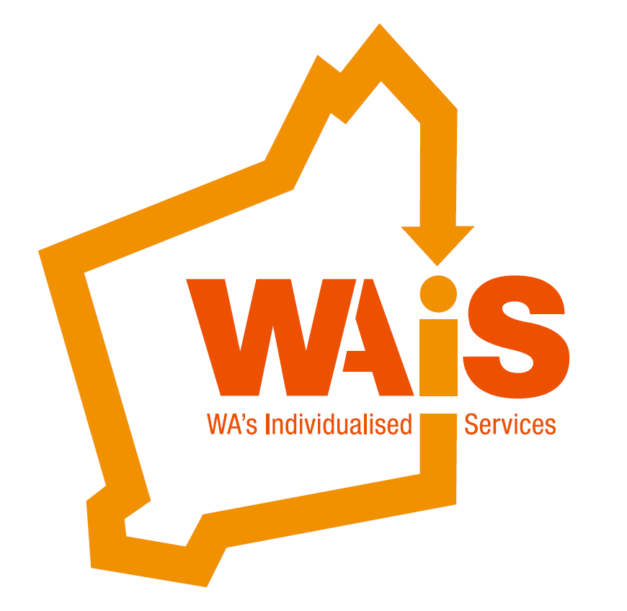

Creating Home

Learnings from Canada

**Presented by: Linda Perry EO**

Vela Microboards (BC) Canada

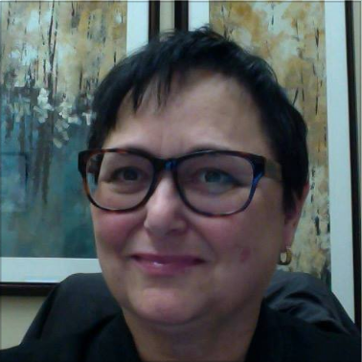

Friday 26th August 2016

9:30am– 12.30pm

Wollaston Conference Centre

5 Wollaston Road Mount Claremont WA 6010

WAIS Member (Individual) $50

Non Member (Individual) $70

WAiS Member(Organisation) $100

Non Member (Organisation): $120

This presentation is suitable for individuals, families and participants across the field of human services.

**Registration is now OPEN !** admin@waindividualisedservices.org.au

08 9485 1997 or book on Eventbrite;

[Register here for Linda Perry 26 August 2016](https://www.eventbrite.com.au/e/linda-perry-creating-home-learnings-from-canada-tickets-26963954915)

A number of factors have affected the evolution of what 'home' looks like for people with disabilities in British Columbia, Canada. The self-advocacy movement, parent advocacy, education of community, and government financial challenges have all had an impact.

When institutions in British Columbia closed a few decades ago, some people were not supported to find housing and became homeless, or received subsidised housing but without supports and were often very lonely. Other people moved in with their families whilst they negotiated the individualised funding process. The result was high levels of anxiety and some chaos, however it was from this space 15 years ago that the real push for alternative models of living began.

Microboards were one of the first organisations to look at creative options for housing. Vela Microboards Canada, has also worked in collaboration with other agencies. Currently some very creative supports around developing ‘home’ have been shaped up and there are more support models emerging. Linda will talk about how these models came to life, and the ingredients for their sustainability.

Linda Perry volunteered on the Vela Microboards Association, Board of Directors, in 1987. She started working for Vela in 1990 and quickly developed the first Microboards, based on the model developed by Faye and David Wetherow in Manitoba, 1984. Linda provides direct support and facilitation to many Microboards and individuals accessing Individualised Funding. organisations.