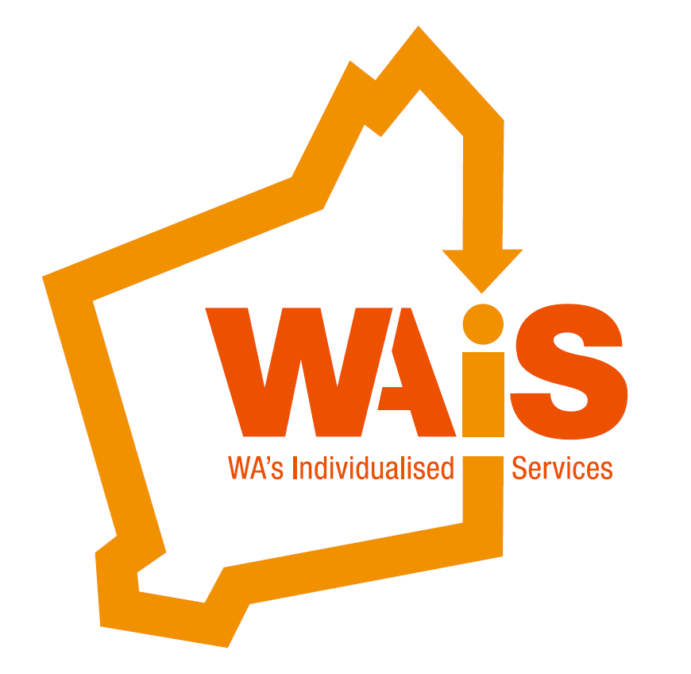

**When Policies Aren’t Enough:** Why Abuse occurs in human services and what can be done about it.

**Presented by: John Armstrong**

Community of Practice

[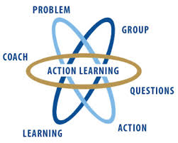](http://www.google.com.au/imgres?imgurl=http://www.wial.org/uploads/attachments/219c70933aff6b2a6d08c687a6cbb6b765.jpg&imgrefurl=http://www.wial.org/about-wial&h=258&w=323&tbnid=we91VuKH8sul9M:&zoom=1&docid=frqClq2y8OCgfM&ei=iPhWVNLjEeG7mwX5hYDgAQ&tbm=isch&ved=0CDkQMygQMBA&iact=rc&uact=3&dur=428&page=2&start=10&ndsp=15)



Action learning

This is a good place to briefly, but effectively, describe your product or services.



Title Text

**When Policies Aren't Enough:** This one day event examines why people in receipt of human services can be ill-treated in the context of their service. As such, this event explores what is known about human natures’ *intrinsic* capacity for harm and violence as well as the *extrinsic* factors that affect behaviour such as cues of an environment, in this instance, the dynamics within human service environments.

In doing so, this workshop will dispel some of the common myths surrounding neglect, harm and abuse, which include elements that may shock certain participants, particularly when it is realised how close to home such actions can become.

Because human services are used frequently by people who are also devalued by society we will examine the contribution poor quality in a service makes to the potential for neglect and abuse. For instance, we generally find the more people are treated in devaluing ways *by the service* the more likely it is that personal abuse and neglect

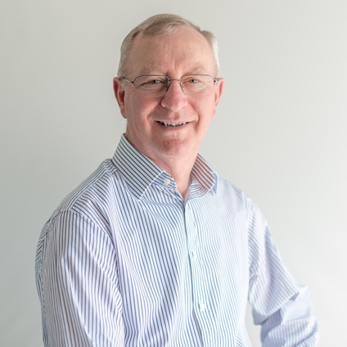

Workshop facilitator John Armstrong

Cost for the 3 day Workshop:

WAiS Members: $449

NON Members: $470

by staff will occur, indeed the service context virtually invites it. Other dynamics will also be identified, such as the contribution of distancing policies and policies in general to worker performance, especially to the loss of values that would otherwise direct worker behaviour.

The workshop explores an array of approaches at the level of government, agency and individual to combat these prospects and includes some of the most powerful ways for people's lives to be safeguarded and protected.

**The training is suitable for participants across the field of human services.**

**For more information please call WAiS on 9485 1997.**



**About the Presenter:**

**John Armstrong**

John Armstrong has worked in government, non-government and in consultancy roles since early 70's as a teacher, principal, adviser and team leader. He has also held statewide training roles – specifically associated with matters of fundamental service practice. He was for eight years a member of the Victorian Intellectual Disability Review Panel. Having been introduced to Social Role Valorisation in the early 80's, he went on to train and receive recognition as a Senior SRV Trainer with Dr Wolfensberger and the Training Institute in Syracuse NY.

Since 1991 he has worked as a self-employed consultant across Australia and New Zealand conducting training, consultancy and evaluation. He has evaluated many human services and provided detailed verbal and written reports that agencies have continued to reference even years later. He also writes material for various newsletters and journals, and conducts workshops and provides keynote presentations at national and some international conferences. John has a particular interest and provides training and articles related to the factors that

promote the welfare of people and reduce the potential for neglect and harm.

Apart from a long involvement in Citizen Advocacy, (as an advocate, board member and CAPE Team Leader) he is the inaugural chair of Citizen Advocacy Australia – a national fund raising body for Citizen Advocacy programs in Australia.

John teaches in English, and is accredited by both the North American Council for SRV and the Australia and New Zealand SRV Group (ANZSG).

**When Policies Aren’t Enough:**

**When:** Thursday 11th August 2016

**Venue:** The Boulevard Centre

99 The Boulevard  
Floreat WA 6014 *Catering provided

**To register please email us;** [**admin@waindividualisedservices.org.au**](mailto:admin@waindividualisedservices.org.au)

**call 08 9485 1997 or book on Eventbrite**

[**https://www.eventbrite.com.au/e/when-policies-arent-enough-why-abuse-occurs-in-human-services-and-what-can-be-done-about-it-tickets-26298170536**](https://www.eventbrite.com.au/e/when-policies-arent-enough-why-abuse-occurs-in-human-services-and-what-can-be-done-about-it-tickets-26298170536)

**Cost for the 1 day workshop**

**WAiS Members:**  $ 190

**Non Members:** $ 210



