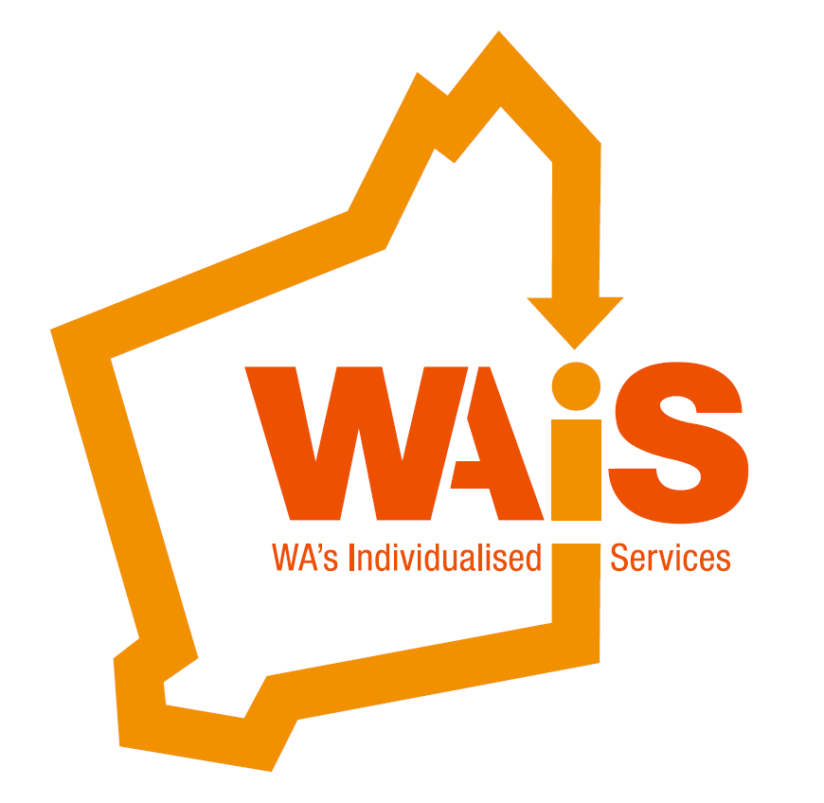

**WAiS Regional Support Worker Roadshow:**  Self-Directed Support and Person Centred Practice

**Presented by: Kate Fulton and Charlotte Van der Burgt**

Community of Practice

[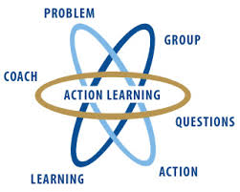](http://www.google.com.au/imgres?imgurl=http://www.wial.org/uploads/attachments/219c70933aff6b2a6d08c687a6cbb6b765.jpg&imgrefurl=http://www.wial.org/about-wial&h=258&w=323&tbnid=we91VuKH8sul9M:&zoom=1&docid=frqClq2y8OCgfM&ei=iPhWVNLjEeG7mwX5hYDgAQ&tbm=isch&ved=0CDkQMygQMBA&iact=rc&uact=3&dur=428&page=2&start=10&ndsp=15)



Action learning

This is a good place to briefly, but effectively, describe your product or services.



Title Text

The **Regional Support Worker Roadshow** consists of two, one day workshops. The first of our Roadshows being in Kalgoorlie!!

The workshops are aimed at getting Support Workers up to speed with the essential elements of Self-Directed Support and Person Centred Practice. This training is ideal for Support Workers who are employed by the person and / or their family or employed by an organisation. This would suit champion Support Workers who can share their learning with colleagues.

**Workshop One - The fundamentals of self- direction and person centred practice**

* Understanding the National Disability Insurance Scheme
* Person centred values and approaches
* Supported Decision Making



**Workshop Two – People’s lives and people’s outcomes**

* Understanding Outcomes and why they matter
* Supporting people to lead full lives, not just supplying support
* Critical Thinking Skills

You can register to come to one or both days of the workshop!

Call WAiS 9485 1997 for further information.

**About the Presenters:**

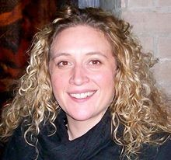

**Kate Fulton:**

Kate has worked alongside people and families for many years working in a range of settings and communities. Kate is passionate about individuals directing their own lives and feels that she has been incredibly privileged to meet people and families who have shared their experiences of helpful supports and creative approaches to change.

Kate Fulton had an active role in leading the self-directed movement in the UK. Since coming to WA she has led WAIS Provider Development series, advising a number of Providers and advising the National Disability Insurance Agency.

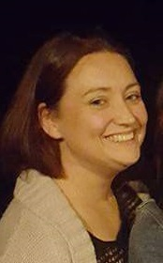

**Charlotte Van der Burgt:**

Charlotte has worked in the disability sector for over 16 years commencing as a support worker herself, continuing on to senior management roles within the sector and holds the position of Individualised Services Advisor with WAiS.

Charlotte has connected with people and families in many regional areas of Western Australia through her various work roles and is loving the opportunity to reconnect with regional areas again.

**Kalgoorlie Regional Support Worker Roadshow**

**When:**

Tuesday 23rd August (Workshop One)

Wednesday 24th August (Workshop Two)

**Time:**

9am (registration) – both days

9:30am – 4pm

**Venue:**

Kookynie Training Room (GIFSA office)

23 Federal Rd

Kalgoorlie, WA

*Catering provided

**To register please book on Eventbrite**

<https://www.eventbrite.com.au/e/kalgoorlie-wais-regional-support-worker-roadshow-tickets-26655110152>

**Cost:**

**WAiS Members (Organisations):**

$150 (one day) $ 270 (both days same support worker)

**WAIS Members Individual (Support Worker employed by person with disability and/or family):**

$75 (one day) $ 120 (both days same support worker))

**Non Members (Organisations**):

$200 (one day) $ 350 (both days same support worker)

**Non Members (Support Worker employed by person with disability and/or family):**

$100 (one day) $ 180 (both days same support worker)

**Provider Development Package**: 2 x Free



