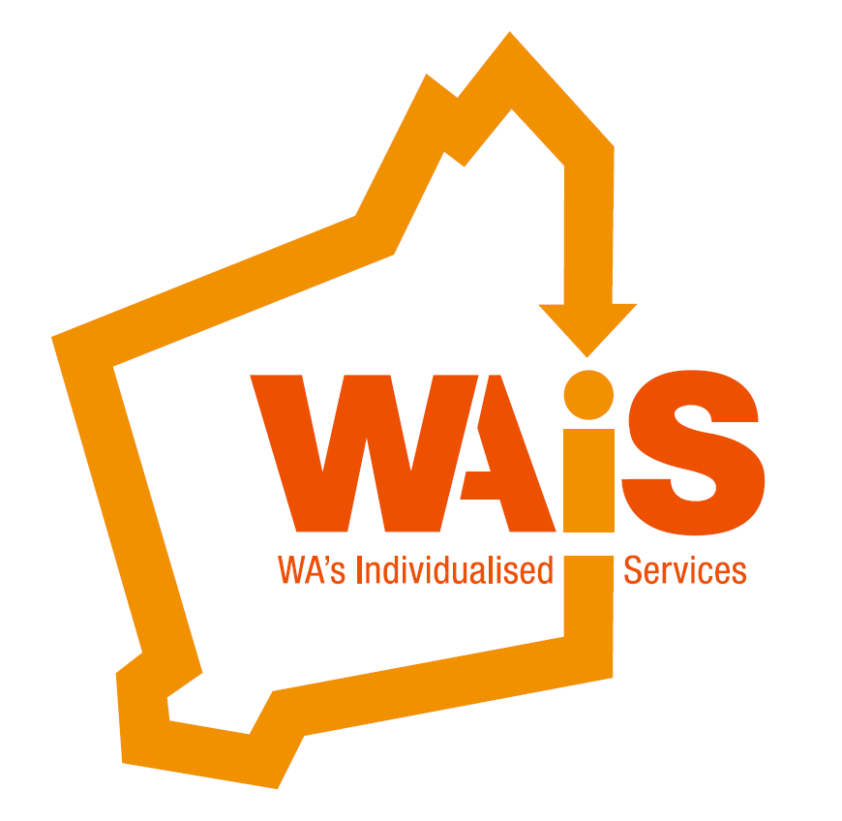

Provider Development Package

Investing in our Future

Registration is now open for 2016-17

Expressions of Interest and Registration is now open for the WA’s Individualised Services NEW Provider Development Package for 2016-17. This subsidised package offers you a suite of tailored supports and development opportunities to help you achieve your organisations strategic goals, operational outcomes, and to strengthen and broaden your capacity to shape and deliver self-directed supports to people and families.

The package includes access to the following:

Six Consultancy and Mentoring days

These consultancy and mentoring days are customised to maximize your success in achieving the outcomes you identify, and can be used flexibly over the year. Organisations have told us that this kind of support has been instrumental in achieving their goals, and have used this support to do everything from Cultural Change programs across their organisation to Governance and Board Support.

Access to a range of Provider Development Workshops

This package also includes access to four workshops, for two staff; chosen from the following key events. These workshops will be within the Perth area*

|  |  |
| --- | --- |
| When policies aren’t enough - Understanding abuse and neglect  Presented by John Armstrong | 11th Aug 2016 |
| Supported Decision Making and Preparing to Plan (2 day workshop series)  Presented by Susan Stanford and Jaquie Mills | 15th Sept and 20th Sept 2016 |
| Creating home - Individual Support Arrangements  Presented by WAiS and Guests | 28th Sept 2016 |
| Leading Culture Change  Presented by Kate Fulton | Oct 18th 2016 |
| Understanding, Designing and Creating Individual Support  Presented by Kate Fulton | Nov 11th 2016 |
| Self and Shared Management  Presented by Leanne Pearman and Su-Hsien Lee | 29th Nov 2016 |
| Understanding the National Disability Insurance Scheme  Presented by WAiS and Guests | 7th Dec 2016 |
| Self-Directing Teams and Local Decision Making  Presented by Kate Fulton | Feb 17th 2017 |
| Coproduction – listening and designing services with customers  Presented by Kate Fulton | 24th March 2017 |

WAiS recommends that you book in early to avoid disappointment

Support Worker Roadshow

The package also gives you access to the Support Worker Roadshow, which is two x 1 day workshops aimed at getting Support Workers up to speed with the essential elements of Self-Directed Support and Person Centred Practice. This program is ideal for Support Workers who are champions and potential influencers across your organisation. The workshops will run throughout metro and regional Western Australia.

Workshop 1 - The fundamentals of self- direction and person centred practice

* Understanding the National Disability Insurance Scheme
* Person centred values and approaches
* Supported Decision Making

Workshop 2 – People’s lives and people’s outcomes

* Understanding Outcomes and why they matter
* Supporting people to lead full lives, not just delivering support
* Critical Thinking Skills

Support Worker Roadshow Dates (some details to be confirmed)

|  |  |
| --- | --- |
| Goldfields, Kalgoorlie | 23rd and 24th August 2016 |
| Perth Metro North | 3rd and 4th November 2016 |
| Perth Metro South | 7th and 8th March 2017 |
| Geraldton | 22nd and 23rd November 2017 |
| Lower Great Southern / Lower South West Albany | Mar / April 2017 (T.B.C) |
| Pilbara/ Kimberley Region | May 2017 (T.B.C) |

Feedback from past participants:

The program helped us to approach work differently….and confirm we are on the right track

It helped us to prepare for changes with the NDIS and to get clear about what we provide across a huge range of programs

WAiS helped us to refocus, and they supported our executive team around shared management…….and to develop good supervision and leadership within our team

Hearing stories helped us to learn about self-management and to develop our strategies for the NDIS

The program helped frontline staff and coordinators to focus on a cultural shift which invoked passion in the organisation

The program has helped to set us up to succeed and continue the work and has helped to clarify the legal and technical issues, and our responsibilities

The financial investment for your organisation to purchase this customised package is $5000. This includes access to 4 workshops for 2 staff- including any resources and information developed, 6 tailored coaching and mentoring days, plus the support worker roadshow workshops. Please note that this fee can be negotiated for small organisations on application. For further information please contact Cath Brindley at WA’s Individualised Services on 94851997 or email; [admin@waindividualisedservices.org.au](mailto:c.brindley@waindividualisedservices.org.au)

Or to REGISTER YOUR INTEREST NOW, complete the following information and return at your earliest convenience to [admin@waindividualisedservices.org.au](mailto:c.brindley@waindividualisedservices.org.au)

(First round applications close Friday 29th July)

Provider Development Package: Investing in our Future 2016-17

|  |
| --- |
| Name of Provider:  Primary Contact Person:  Telephone and Email details:  Organisation website:  Location of organization/geographical areas you service: |
| Please briefly describe your organisation including; how many people you support, specialty areas of support, and the range of supports your organisation offers. |
| As an initial projection, what key areas do you foresee your organisation requiring support with and why? |
| Please tell us what outcomes you hope to achieve from your Participation in the Provider Development Package |
| Name of the person who completed this application form |

**Thank You**