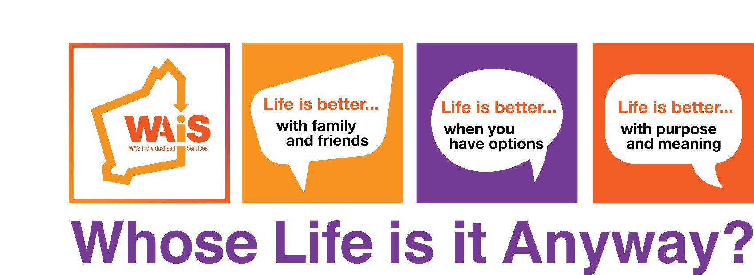

**Register online at:**

**www.eventbrite\***

**Call 08 9485 1997**

**Conference**

**Sunday 8th May 2016: ‘Sundowner’ 3.00pm until 6.00pm   
and**

**Monday 9th May 2016: 9.30am until 4.30pm**

**With International Guests**

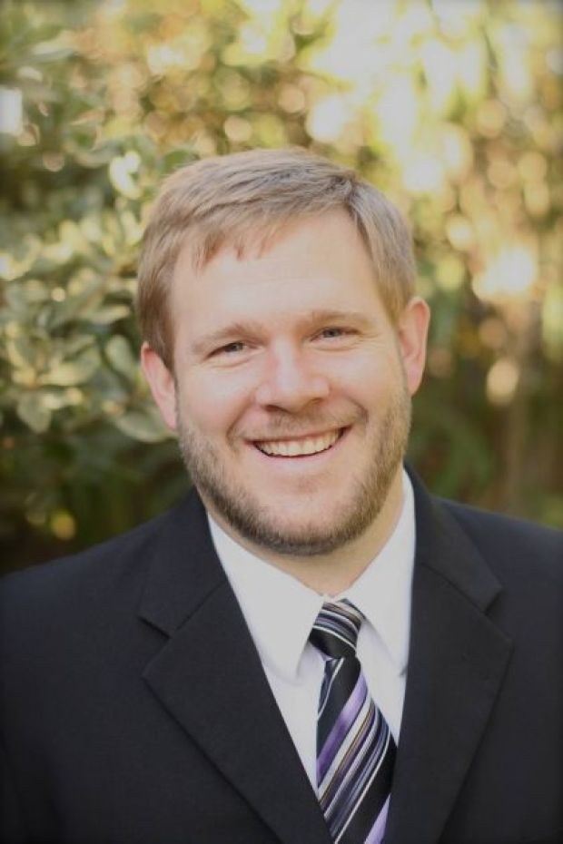 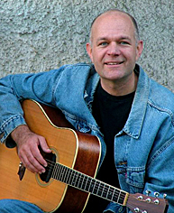

**Stephen Hinkle & Peter Leidy**

**TRAVEL SUBSIDIES**

**We encourage people with disabilities and their families who live in regional areas to apply for travel and accommodation assistance. For more information please contact: 9485 1997 or Bron at b.pike@waindividualisedservices.org.au**

**WAiS would like to thank Lottery West for this regional travel assistance**



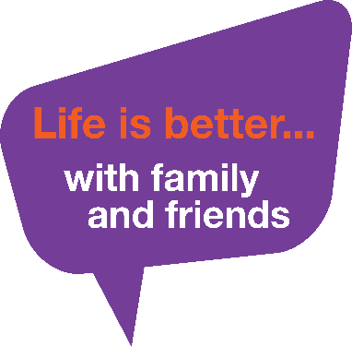 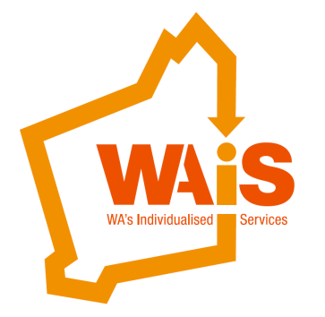

**Conference Program**

Sunday 8th May 2016

‘Sundowner’

3.00PM – 6.00PM

|  |  |
| --- | --- |
| 3.00PM – 4.00PM | Welcome  We invite you to join in the fun as we open our conference with live music, art and activities.  Have your say at our Filming Booth where we will be creating a film throughout the 2 days, make your own drum to use in the workshop, and be part of a conference art project. Feel free to bring your own percussion instrument. It’s also the perfect time for us all to celebrate Mother’s Day ☺ |
| 4.00PM – 5.00PM | ‘Making Connections’  **An interactive workshop with Peter Leidy, Stephen Hinkle and local guests.**  Through real stories and music, Peter will explore the theme of connection, community life and relationships - how do we build and keep meaningful relationships with friends and family? What are the real barriers to connecting with each other in our community? This is an interactive workshop which aims to be informative, practical and fun. |
| 5.00PM – 6.00PM | Time to continue the celebrations with each other and enjoy fabulous cocktail food, drinks and entertainment. |

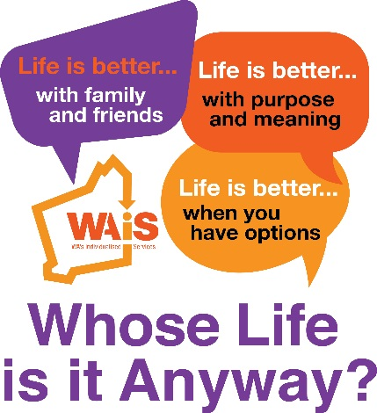

**Conference Program**

Monday 9th May 2016

9.30 AM – 4.30 PM

|  |  |
| --- | --- |
| 9.30AM | Registration |
| 10.00AM | Opening Address and Welcome to Country  Davina Paul, Leanne Pearman and Shaun Nannup |
| 10.30AM | Keynote Address: Stephen Hinkle  **Human Rights – Whose Life is it Anyway?**  A leading international speaker, disability rights self-advocate, and education consultant, Stephen will speak about how human rights and citizenship are the foundations for having a good life. |
| 11.00AM | Keynote Address: Peter Leidy  **Power, Control, Choice- Whose Life is it Anyway?**  Peter is a consultant, facilitator, listener, learner, improviser, and speaker who focuses on personalised supports and community membership for people with disabilities.  In his opening address, Peter will explore the meaning behind power and control in support relationships and question what choice really means to each of us. |
| 11.30AM | Keynote Address : Ben Keely  **‘Life is better with friends’**  Ben will share his experiences about how his life has changed for the better and how his friendships helped him achieve it |
| 12.00- 1.00PM | Lunch |
| 1.00- 2.00PM | Workshop Series One:   **“Life is better when you have options”**   |  |  |  | | --- | --- | --- | | **Orange Room** | **Purple Room** | **Red Room** | | Stephen Hinkle  Self Advocacy – speaking up and making decisions for ourselves | Liz Dutton and The Johns Family  Two powerful local stories about how having REAL options changed their life | Peter Leidy, Heather Simmons and Lauren Marchbank  Unlocking Creativity, Getting Results, Having Fun | |

|  |  |  |  |  |  |  |  |
| --- | --- | --- | --- | --- | --- | --- | --- |
| 2.00-3.00PM | Workshop Series Two:  “Life is better with purpose and meaning”   |  |  |  | | --- | --- | --- | | **Orange Room** | **Purple Room** | Red Room | | Stephen Hinkle and local talented musician  Having high expectations- the difference between a life with purpose and a life that others place upon you | Kate Fulton and Leanne Pearman WAiS  Life By Line Item? | Peter Leidy  We’re all in this together: Staying focused on the person in challenging times | |
| 3.00- 3.30PM | Afternoon Tea |
| 3.30-4.30PM | It’s a Wrap … Lights, Camera, Action…  Our two days conclude with an open forum ‘Q&A’ with our International and Local Friends, Live Music with Peter Leidy and see yourself on Film!  Hosted by Leanne Pearman and Davina Paul |

**Art Music Film Fun**

Running throughout the conference there will be opportunities to get involved in a number of creative activities: visit the art exhibition, take part in our live film making session with professional film makers ALUCINOR PRODUCTIONS, make your own instrument and help us to make a conference art piece by contributing your own piece of the puzzle.

**Registration is now open**

FREE for WAiS Individual Members*

$95.00 for Individuals (non-member)*

$290.00 for WAiS Organisation Members

$390.00 for General Admission

*People who have a disability

Registration includes all conference sessions on Sunday and Monday; full catering and conference resources and materials.

[Register Here on Eventbrite](https://www.eventbrite.com.au/e/wais-conference-whose-life-is-it-anyway-tickets-20750472221) or phone 08 9485 1997

Eventbrite: https://www.eventbrite.com.au/e/wais-conference-whose-life-is-it-anyway-tickets-20750472221

Venue  
The Bendat Parent and Community Centre  
36 Dodd Street, Wembley

Western Australia

ph: 9387 9888

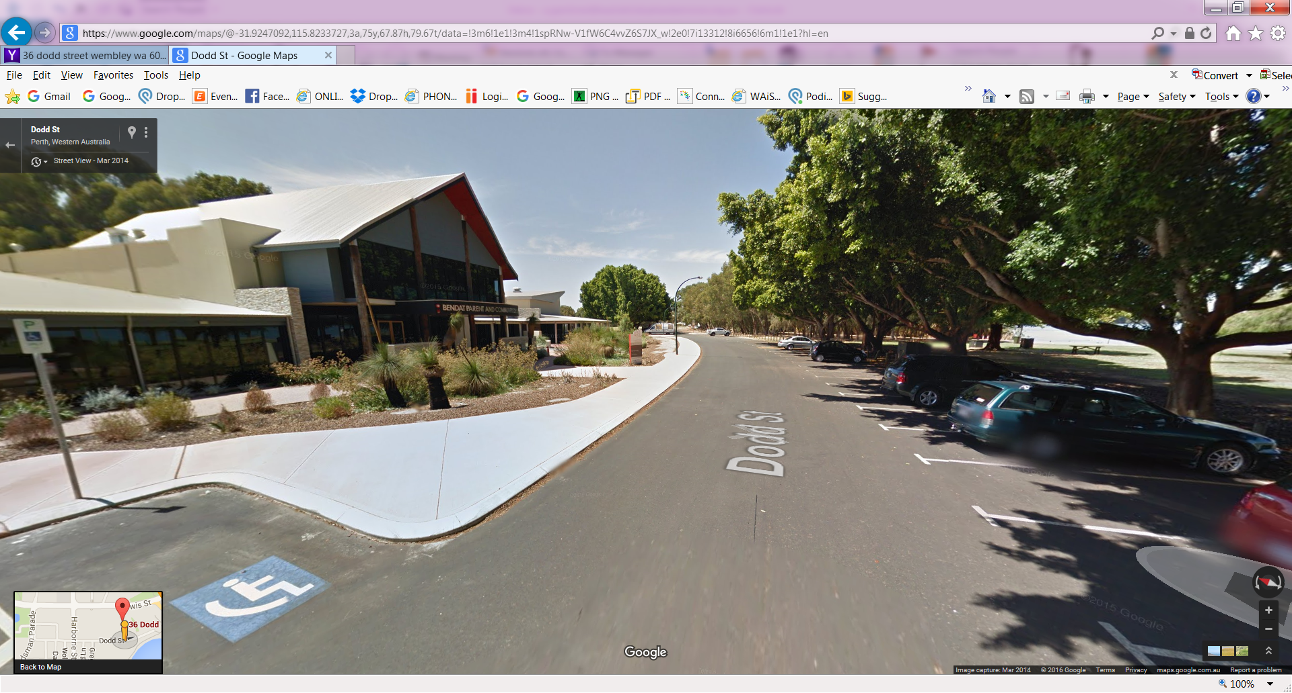 [Google Map Link](https://www.google.com/maps/place/36+Dodd+St,+Wembley+WA+6014,+Australia/@-31.923845,115.8210003,17z/data=!3m1!4b1!4m2!3m1!1s0x2a32a561785252cb:0x757ab3b1e23815f4?hl=en)