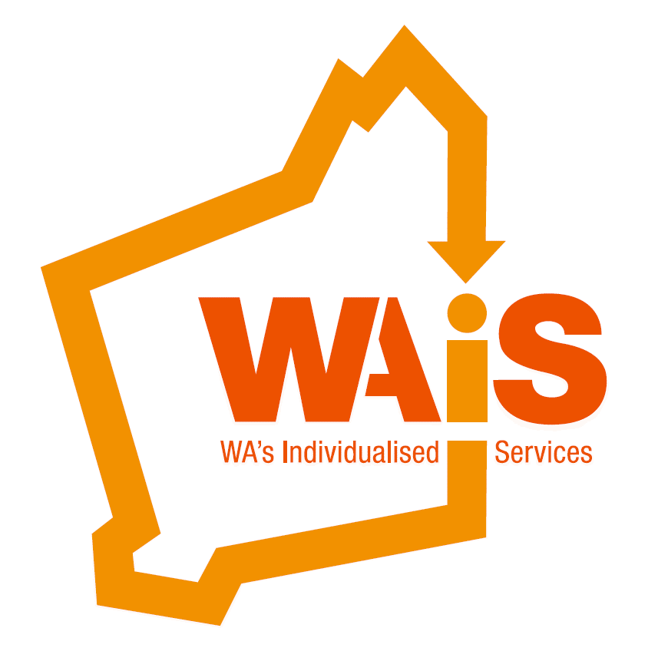  - Save the date  ‘Whose life is it anyway?’  A conference for everyone  WA’s Individualised Services is excited to be hosting a two-day conference in May 2016. We invite you to join us and our international friends Stephen Hinkle and Peter Leidy for a few days of sharing and learning, with a bit of fun thrown in.  Stephen Hinkle is a well-respected international speaker and self-advocate. Stephen has been presenting and speaking for over 15 years. He has influenced audiences and successfully advocated for inclusive education and better outcomes for people with disability.  Peter Leidy has been learning from people with disabilities since 1983. Peter is a consultant, facilitator, listener, learner, improviser, and speaker who focuses on personalized supports and community membership for people with disabilities. He also writes and sings songs about human serviceland and those who find themselves connected to it.  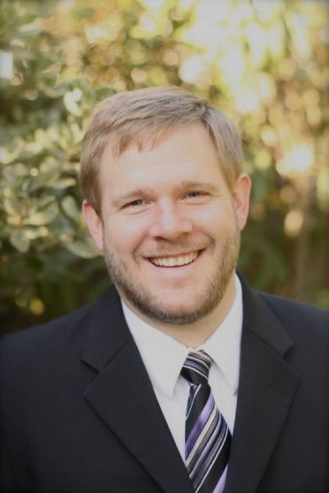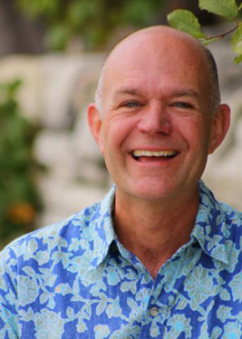  Stephen Hinkle Peter Leidy  * NOTE: There will be significant concession rates for people with disability and their families to attend. This could also include travel assistance for people/families in regional areas. |  | 8th – 9th MAY 2016  Sunday and Monday at the Bendat Parent and Community Centre, Wembley  Stephen Hinkle  Peter Leidy  More information will be sent in coming weeks, however, save this date and express your interest in attending this WAiS conference by emailing us admin@waindividualisedservices.org.au  9485 1997  Follow us on  

