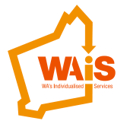**A conference for everyone**

**‘Whose life is it anyway?’**

There will be a 2 day conference in May 2016.

We would love you to come.

We have 2 international speakers, Stephen Hinkle and Peter Leidy.

You will learn and have fun.

The cost for people with disability and their families is less.

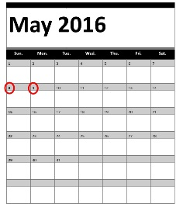

Date: 8th and 9th May 2016

Where: Bendat Parent and Community Centre, Wembley



Please call WA Individualised Services on 9485 1997



Email [admin@waindividualisedservices.org.au](mailto:admin@waindividualisedservices.org.au)