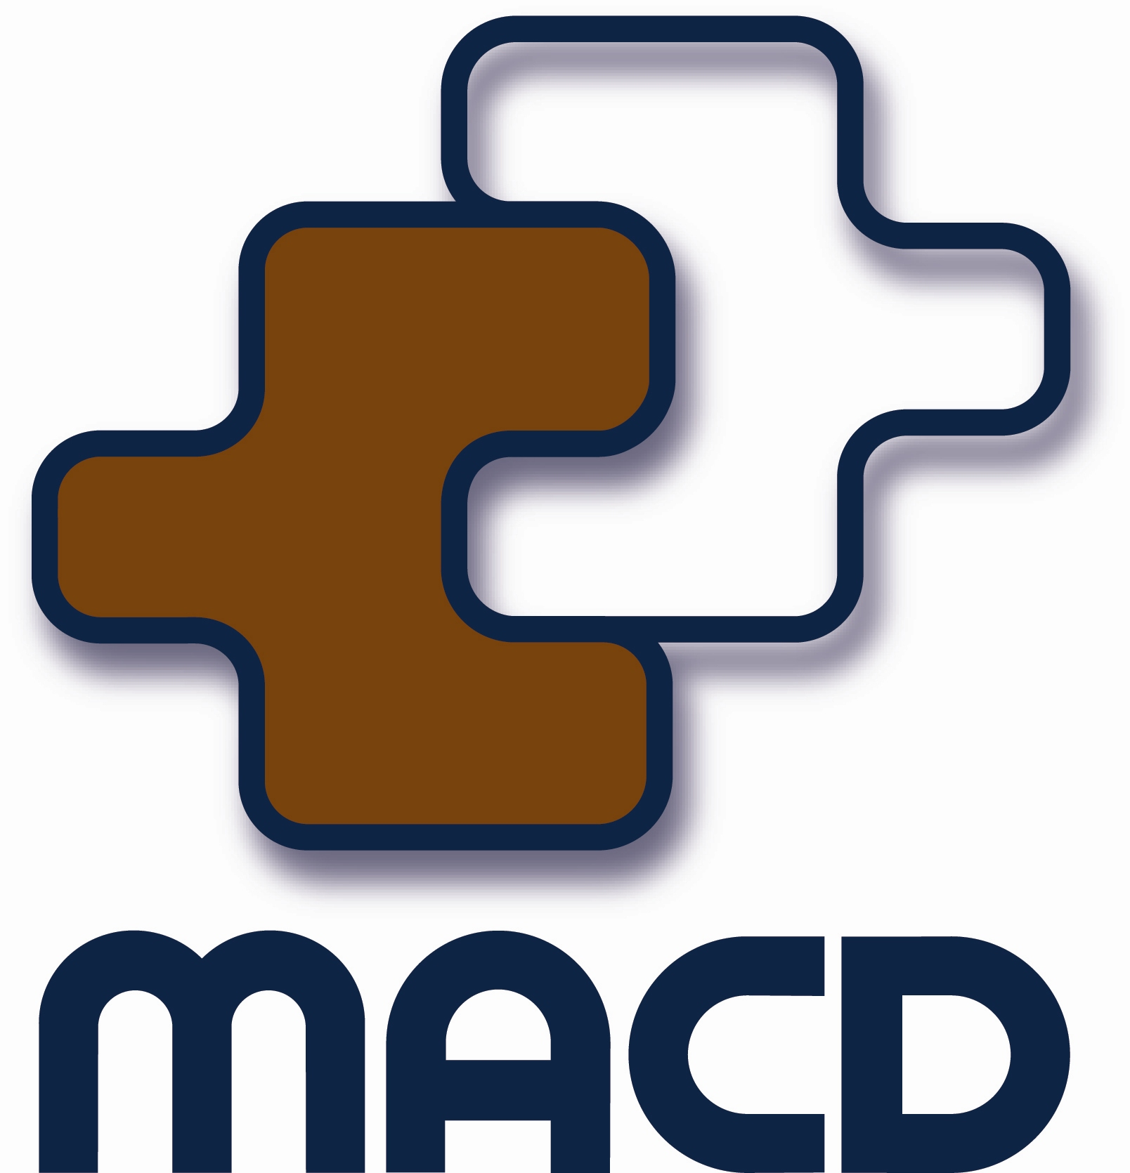
Ministerial Advisory Council on Disability

Information Paper

Self Directed Services – Putting You in charge of Your services
Disability Services is moving towards a more self-directed approach, where people with a disability will have more flexibility and control of the supports they choose.

The Minister for Disability Services, the Hon Helen Morton MLC, is keen to find out what self directed services means to people with disability, their families and carers and the service sector.

This is your chance to tell the Minister's Advisory Council your thoughts on self directed services and what it would mean to you to have more say in how you receive your services.

As well as wanting to hear from people with disability, the MACD would like input from families, carers, advocates and service providers to gain a wider perspective of the issues.

About us
The role of the Ministerial Advisory Council on Disability (MACD) is to advise the Minister on issues that impact on the lives of people with disabilities, their families and carers. The MACD is an independent consumer based body and exists to ensure that the interests of people with disability, their families and carers are adequately represented to Government.

About Self Directed Services
There are changes occurring with the delivery of disability services at a local and national level. There will be opportunities for people to have greater control of the supports and services they need to have a better life.

With the Economic Audit Committee report recommending changes to the delivery of human services across Western Australia and the Productivity Commission’s National Disability Care and Support Scheme being worked on across Australia, it is now time to gather your views on how you think it may affect you.

Some characteristics and elements of self directed services may include:
- Planning directed by the individual as much as possible
- Choice and flexibility
- Person Centred approach
- Funds to meet your disability support needs
- Think about what supports are needed, and how they should be provided.
- Individual support package

Self directed services means you have more choice and control of the services you receive. You choose the method you wish to use. You may want to self manage your funding and services yourself or have someone close to you that can do it. You may like to have an organisation make the arrangements and get them to do all the paperwork and arrangements. But it is about what you choose to do that suits your life and not what suits the systems and services that exist. You choose what works best for you and what can give you a better life. There are a range of options that can be used to manage your funding. Some are listed below:

- Funds are provided directly to you (individual with a disability).
- A family member or someone close that you trust could manage your funding on your behalf.
- a micro-board or 'circle of support' could manage your budget and funding and have regular contact with you to ensure your choice and control is maintained.
- a financial intermediary (FI), a bit like a bank, where the person (or family member on behalf of a person) has control of the things that are purchased, but the invoices are sent to the FI who pays them and sends monthly statements to the person.
- Funding goes direct to an organisation of your choice but the planning and control is with the person and their family.
- Funding goes to a case manager/broker who works with the person and/or family to develop and implement their plan, purchase services and undertake accountability.

The idea of self-directed funding is where the person with a disability and their families and those that care about them make the decisions about their life as much as possible.

This model also incorporates the option for people to employ their own support workers, use an agency to do payroll (insurance, tax, etc.), or negotiate a shared management model with a service provider.

The key is simplicity. A good system is a one that is easy for everyone to use, so it is important that Governments have good regard for this as they introduce self-directed funding. No matter which of the above options you choose, a good system is one where you have central control over the decisions that affect you.

About the consultation
The MACD is conducting this consultation to gather feedback from people with disability, their families and carers, advocates and services providers on self directed services. We have provided a number of ways so that all people can have a say (see under “How you can have your say” below).

The four key areas identified include:
- understanding what self directed services means to an individual and their families
- what support and advice people may need to successfully self direct their services
- what accountability and safeguards will need to be put in place
- what impact will there be on the service sector.
How you can have your say
You may provide comment in any way that is easiest for you. Some ways include:

Attend a public forum

Perth Tuesday 27 September 2011 from 9.30am to 2.00pm
Loftus Recreation Centre, Cnr of Loftus Street and Vincent Street, Leederville
Upper Function Room.

Country Venues, dates and times for the country forums have not been finalised yet. If you wish to register your interest to receive notification of these forums please contact the MACD office.

Written submissions - feedback form
Contact the MACD office for a feedback form or visit the MACD website where you can complete the form online.

Online feedback form:
SDS feedback form for people with disability, families and carers
SDS feedback form for service providers and advocates

Email: advisory@dsc.wa.gov.au

Post: Ministerial Advisory Council on Disability
PO Box 441, West Perth WA 6872

Telephone: (08) 9426 9269 - Gail Ambrose
1800 629 269 (freecall for country callers)

TTY: (08) 9426 9321 (for deaf and hard of hearing people)

Fax: (08) 9226 2316

MACD Website: www.macd.wa.gov.au

What happens with the information gathered?
The MACD will develop a report of the information and discussions and provide it to the Minister for Disability Services.

The MACD anticipates that the information in this report will assist the Minister in the development of self directed services to meet the needs of people with disability, their families and carers in Western Australia to live a better life.

Submissions close 30 November 2011

